CXBanking

OptiVLM Carrier Web 10.0

User Reference Guide

**Build 4027**

**Version 10.0**

**March 2023**

Copyright and Trademark Information

If this guide is distributed with software that includes an end-user agreement, this guide, as well as the software described in it, is furnished under license and may be used or copied only in accordance with the terms of such license. Except as permitted by any such license, no part of this guide may be reproduced, stored in a retrieval system, or transmitted, in any form or by any means, electronic, mechanical, recording, or otherwise, without the prior written permission of NCR Incorporated. Please note that the content in this guide is protected under copyright law even if it is not distributed with software that includes an end-user license agreement.

The content of this guide is furnished for informational use only, is subject to change without notice, and should not be construed as a commitment by NCR Incorporated. NCR Incorporated assumes no responsibility or liability for any errors or inaccuracies that may appear in the informational content contained in this guide.

OptiCash, OptiNet, OptiVault, OptiCashMI, OptiVLM, OptimizeCF, OptiSuite, OptiRecon, and OptiBridge are trademarks of NCR International Inc.

Adobe Acrobat Reader is a registered trademark of Adobe Systems Incorporated. Microsoft, Windows, and Windows Vista, Internet Explorer (IE) are either registered trademarks or trademarks of Microsoft Corporation in the United States and/or other countries. Solaris is a Trademark or registered trademark of Sun Microsystems, Inc. in the United States and other countries. Oracle is a trademark of Oracle in the United States and other countries. WebSphere is a trademark of IBM in the United States and other countries. UNIX is a trademark in the United States and other countries, licensed exclusively through X/Open Company, Ltd. All other trademarks are the property of their respective owners.

Copyright © NCR. All Rights Reserved

Revision Record

|  |  |  |
| --- | --- | --- |
| Date | Page No. | Description of Change |
| 10 March 2023 | All | Formatting Changes |
|  |  |  |
|  |  |  |

Contents

Copyright and Trademark Information 2

Revision Record 3

Contents 4

1 INTRODUCTION TO CARRIER WEB 7

1.1 CONVENTIONS USED IN THIS HELP DOCUMENTATION 7

1.2 GETTING STARTED 8

1.2.1 SCREEN RESOLUTION 8

1.2.2 NAVIGATION TIPS 8

1.2.3 ACCESSING VAULT BALANCE 8

1.2.4 LOGGING IN 9

1.2.5 LOGGING OUT 9

1.3 INTERFACE OVERVIEW 9

1.3.1 MAIN MENU TABS 10

1.3.2 COMMON CARRIER WEB ICONS AND BUTTONS 10

1.3.3 DATE SELECTOR 11

2 DASHBOARD 13

3 EMPLOYEES 15

3.1 LIST ALL EMPLOYEES 16

3.2 IMPORT EMPLOYEES 17

4 DEPOTS 18

4.1 LIST DEPOTS 18

4.2 SHOW DEPOT 19

4.3 IMPORT VAULT HISTORY 20

5 ORDERS 21

5.1 CREATE ORDER 21

5.2 CREATE ORDERS - DENOMINATIONS 22

5.3 CREATE ORDERS - MAINTENANCE VISIT 23

5.4 LIST BY WORKFLOW 24

5.5 SHOW MANIFEST 27

5.6 SHOW ORDER 28

5.7 EDIT ORDER 30

5.8 SEARCH ORDERS 32

5.9 EXPORT ORDERS 34

5.10 IMPORT ORDER UPDATES 35

5.11 IMPORT ATM RESIDUALS 35

5.12 VIEW DISPUTES 36

5.13 INPUT DISPUTES 37

5.13.1 Create/Update Dispute Details 38

6 ROUTES 41

6.1 CREATE NEW ROUTE 41

6.2 LIST ALL ROUTES 41

6.3 ROUTE PLAN DOCUMENT 42

6.4 ROUTE PLAN AUDIT 44

6.5 CREATE/UPDATE ROUTE PLAN DETAIL 44

6.6 MANAGE TRUCKS 47

6.7 SHOW TRUCK 48

6.8 CREATE NEW TRUCK 49

6.9 MANAGE DEFAULT ROUTES 50

6.10 SHOW DEFAULT ROUTE 51

6.11 UPDATE DEFAULT ROUTE 52

7 CONTAINERS 54

7.1 IMPORT CONTAINERS 54

7.2 CREATE NEW CONTAINER 54

7.3 CONTAINER BULK CREATION 56

7.4 LIST ALL CONTAINERS 57

7.5 CONTAINER LOCATIONS 60

7.6 CONTAINER ALERTS 62

8 REPORTS 64

8.1 ROUTE PLAN SUMMARY REPORT 64

8.2 ATM RESIDUALS REPORT 65

8.3 CONTAINER ASSET REPORT 66

8.4 CONTAINER USE BY LOCATION REPORT 67

8.5 VAULT LOAD HISTORY REPORT 68

9 SETTINGS 70

9.1 WORKFLOW CONFIGURATION 70

9.2 SYSTEM SETTINGS 71

9.3 USERS 72

9.4 UPDATE USER 74

9.5 USER GROUPS 74

9.6 SHOW USER GROUP 75

9.7 CREATE OR EDIT USER GROUP 76

9.8 ORDER CUSTOM FIELDS 77

9.9 ROUTE FIELD CONFIGURATION 77

9.10 ROUTE PLAN WORKFLOW 79

9.11 VAULT LOAD CONFIGURATION 80

9.12 NOTIFICATION HISTORY 81

10 Mobile CarrierWeb 83

10.1 PACKAGE ORDER 83

10.2 ARRIVAL 85

10.3 DEPARTURE 88

10.4 CONTAINER STOCK 90

11 APPENDIX A: OPTITRANSPORT 93

11.1 SHORTEST PATH CALCULATION PANEL 93

# INTRODUCTION TO CARRIER WEB

OptiVLM (Vault Logistics Management) is a multi-module solution. Refer to TABLE 1:OPTIVLM MODULES. OptiVLM integrates with OptiSuite (OptiCash, OptiNet, and OptiVault) data to provide multi-user access to real-time updated information regarding ***currency inventory*** and ***orders*** as they move between financial institutions, central banks or other cash sources, and armoured car networks.

TABLE 1:OPTIVLM MODULES

|  |  |
| --- | --- |
| Module | Description |
| **Invoice Validation** | Compares invoices related to cash transportation activities with activity records from OptiSuite. Invoice Validation searches for discrepancies in services rendered amounts transported and applied billing rates. |
| **Carrier Web** | Provides an interface for carriers (armoured car vendors) to access and update order status. Carrier Web also provides access to branches' information regarding authorized carrier personnel. |
| **Vault Balance ** | Utilizing OptiSuite activity, Vault Balance provides real-time updates for your vaults’ balances and activity. |

OptiVLM is hosted and managed by the financial institution, but the different modules may be accessed and operated by external users including the vaults and armoured car vendors.

**This User Guide is for the Carrier Web module. For user information relative to the Invoice Validation or the Vault Balance interfaces, Kindly refer to the respective guides.**

|  |  |
| --- | --- |
|  | **Caution**: OptiVLM is a live application. Changes that are made in the application are permanent and can affect the operation of the system. There are limited undo capabilities for the users; therefore, be sure to consult this manual before deleting or changing system parameters. |

## CONVENTIONS USED IN THIS HELP DOCUMENTATION

The conventions used in this help documentation are shown in the table below.

TABLE 2: CONVENTIONS

|  |  |
| --- | --- |
| Convention | Use |
| Green Text | Indicates a link to the top of the current section. These links can be clicked to quickly navigate through this document. (In some cases, you may need to hold the CTRL key to click the link) |
| Blue Text | Indicates a link to a different topic or section. These links can be clicked to quickly navigate through this document. (In some cases, you may need to hold the CTRL key to click the link) |
| **→ ** | The “arrow” sign indicates a menu choice. **For example**, "**Choose File** → **Open**" means "click the File menu, and then click Open." |
|  | Used to warn users of potential problems or to take caution when making changes to settings and parameters. |
|  | Tips or information that may help use the functionality. |

## GETTING STARTED

**Carrier Web** is a web-based application that automatically updates itself in real-time based on OptiSuite activity. As currency moves among the various cashpoints (ATMs, Branches, Vaults), Carrier Web will reflect the real-time activity.

### SCREEN RESOLUTION

Because OptiVLM runs in a browser, the user may choose any valid desktop resolution, and OptiVLM will resize automatically. 1024x768 resolution or larger is recommended to minimize scrolling on some of the screens containing large information.

### NAVIGATION TIPS

When using OptiVLM, avoid using the Back and Forward buttons  in the browser. All navigation should occur within the application via the **menu** or **icons** thereby insuring the successful processing of the OptiVLM system.

### ACCESSING VAULT BALANCE

To begin using the application, enter the required OptiVLM URL in the browser.

|  |  |
| --- | --- |
|  | **Suggestion**: Save the OptiVLM URL in the Favorites folder for easier future access. |

### LOGGING IN

Carrier Web will launch within the browser. Security is supplied via external authentication via your systems network logon. If you are not already logged in via network authentication you will be prompted for a username and password. To login, enter your **Username** and **Password** and click **Login**.

|  |  |
| --- | --- |
|  | **Note**: For **External Authentication**, the Login prompt will not be displayed. Login will be automatic based on network authentication. |

### LOGGING OUT

To log out, simply close the browser or log out via an external authentication method.

## INTERFACE OVERVIEW

The following section will show examples of the Carrier Web interface pages and explain the functionality, purpose, or use of each page. This section is a reference when working with the application on a daily basis.

In order to keep this manual as succinct as possible, the user interface is described in this section. Other chapters throughout the manual will then refer to the appropriate section of the user interface to avoid duplicate screens, images, and text.

This chapter has been broken into different sections to make it easier for readers to find the information. The General topics are broken into the **Main Tabs** or **Functions** with all associated information contained beneath the sections. The following hyperlink is a summary of each topic that will be covered.

* MAIN MENU TABS
* COMMON CARRIER WEB ICONS AND BUTTONS
* DATE SELECTOR

### MAIN MENU TABS

The user can control Carrier Web operations through the main menu tabs, **for example**, See FIGURE 1: MAIN MENU TABS. After selecting the menu items, additional options are displayed, until a final menu option is reached, allowing full access to all functions.

FIGURE 1: MAIN MENU TABS

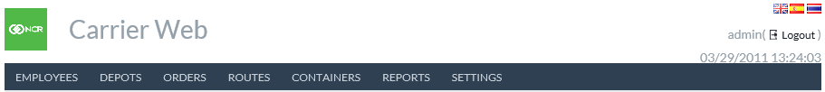Return to: Interface Overview

|  |  |
| --- | --- |
| Tabs | Description |
| **Employees** | Access the controls for entering Depot/Carrier employee information. Carriers can enter descriptive information that will allow vaults and branches to ensure the identity of the carrier personnel they interact with |
| **Depots** | Access listings of all associated depots and the cashpoints (ATM, Branch, and Vault) that each depot services |
| **Orders** | Access the ability to list all orders by type, upload order update files, and export orders |
| **Routes** | Access route planning and the trucks including type and capacity |
| **Reports** | Access reports of Carrier Web activity |
| **Settings** | Access the parameters and settings associated with Carrier Web |

TABLE 3: MAIN MENU TABS

Return to: Interface Overview

### COMMON CARRIER WEB ICONS AND BUTTONS

The user should become familiar with common icons and buttons that are used throughout the application. TABLE 4: OPTIVLM-CARRIER WEB ICONS is an overview of icons and its functions.

TABLE 4: OPTIVLM-CARRIER WEB ICONS

| Icon | Description |
| --- | --- |
|  | **New Icon:** Add a new record. |
|  | **View Icon:** View a specific record. |
|  | **Update Icon:** Update a specific record. |
|  | **Delete Icon:** Delete the associated record. |
|  | **Export to CSV:** Exports screen contents to a **.CSV** report for external analysis |
|  | **English** language indicator |
|  | **Spanish** Language indicator |
|  | **Thai** Language indicator |
|  | **Save**: Allows changes made on the screen to be permanently saved to the appropriate file |

Return to: Interface Overview

### DATE SELECTOR

In several areas of the application, it may be necessary to select or change a date for reports, orders, etc.

FIGURE 2: DATE SELECTOR

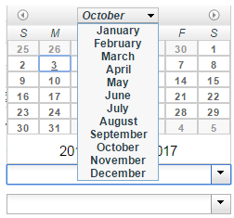

Return to: Interface Overview

TABLE 5: DATE SELECTOR DESCRIPTION

|  |  |
| --- | --- |
| Field | Description |
|  | Moves the Calendar 1 month forward or backward |
| **Dates** | Selects the date of the month to be searched for |
| **Years** | Specifies the year to be searched |

# DASHBOARD

The Dashboard page is the landing page when logging into the app and can be accessed by clicking on the **logo** i.e., on the top left corner of the page.

FIGURE 3: DASHBOARD SCREEN

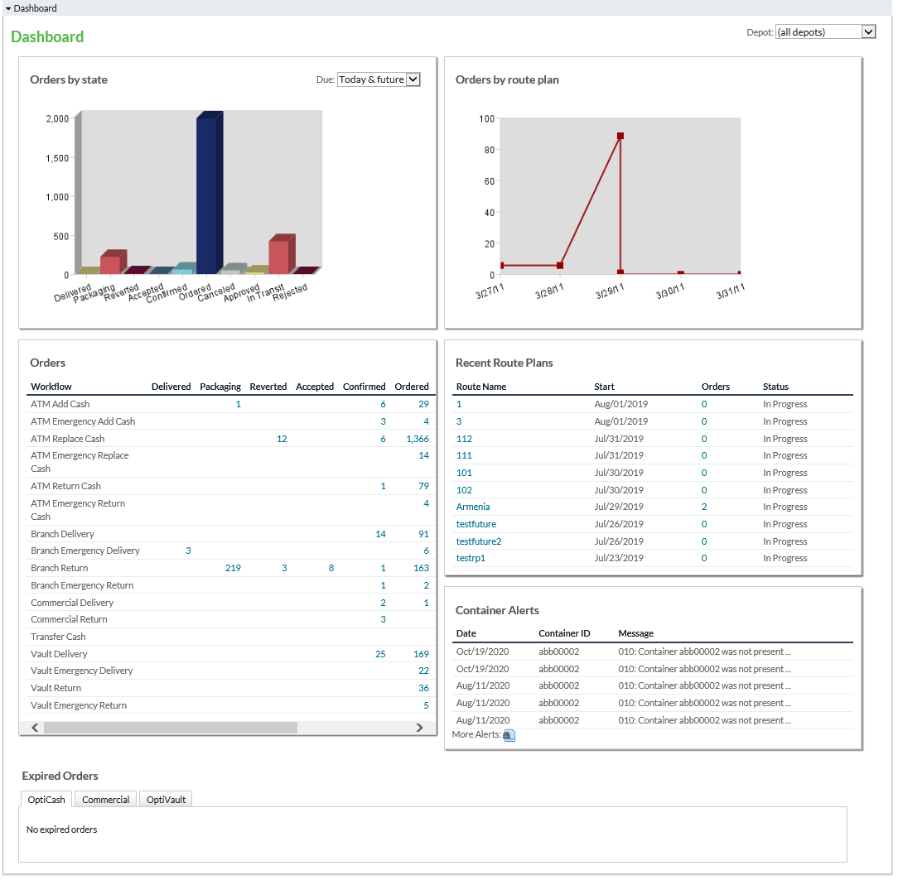

Return to: Dashboard

TABLE 6: DASHBOARD SCREEN

|  |  |
| --- | --- |
| Field | Description |
| **Orders Bar Chart** | The number of orders per state is identified by counting all orders visible to the user in each state.  The states are “**view states**” defined in Carrier Web, i.e., the states that the user is allowed to view. |
| **Orders Table** | The order amounts in each workflow and state. All workflows visible to this user will be shown. Clicking an amount takes the user to the **Order Search** page with the relevant orders listed |
| **Route Plans Line Chart** | The number of orders delivered in the last 7 days. The Y-axis shows the number of orders. This chart aggregates all route plans for a given date. |
| **Route Plans Table** | The list of the last 10 route plans is sorted by date. Each route plan shows the number of orders. Clicking the route plan name takes the user to the route plan view page. Clicking the number of orders takes the user to the **Order Search** screen and displays the orders. |
| **Container Alerts** | Lists the most recent container alerts, with a link to view more alerts if desired. |
| **Expired Orders** | Shows the ***OptiCash***, ***Commerical*** and ***OptiVault*** orders that are currently in the expired state, with each type of order in their tab. Orders can be viewed by clicking on the view icon in each order row. |

Return to: Dashboard

# EMPLOYEES

Carrier Web allows descriptive information about carrier employees, which will be saved in the software and then accessed by **Vaults** and **Branches** serviced by the carrier. This adds an additional security measure so that carrier clients can verify the identity of the armoured car staff.

The information includes the Employee's picture, Eye color, Hair color, Height, Weight, and Badge ID may be included in each Employee Profile.

FIGURE 4: CREATE NEW EMPLOYEE

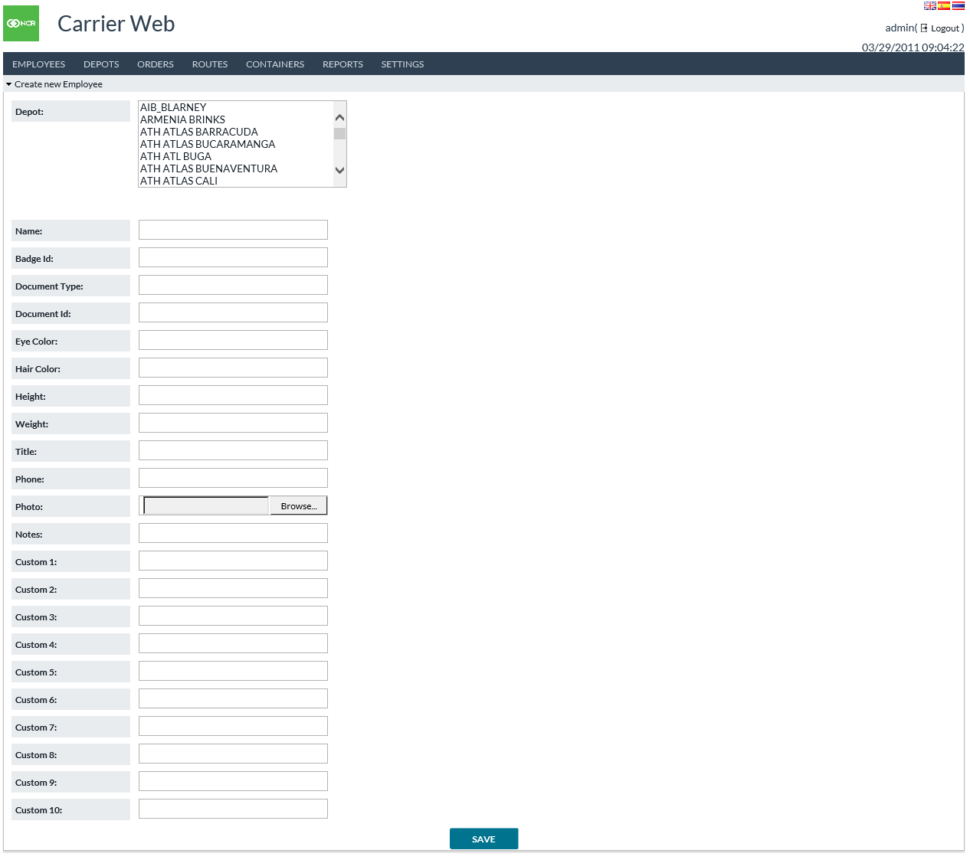

TABLE 7: CREATE NEW EMPLOYEE FIELD DESCRIPTIONS

|  |  |
| --- | --- |
| Field | Description |
| **Depot** | Carrier Web connects each employee to one or more Depots. When setting up Employees, Administrators select the corresponding Depots from the menu. |
| **Name** | Employee’s Name |
| **Badge ID** | Badge identification number for each employee |
| **Document Type** | Employee’s identification document (National ID, Passport, Driver’s License, et al) |
| **Document ID** | Unique identification number of the employee’s ID |
| **Eye Color** | Employee’s Eye Color |
| **Hair Color** | Employee’s Hair Color |
| **Height** | Employee’s Height. Since it is a text field, it can be a metric or English measurement |
| **Weight** | Employee’s Weight. Text fields like Height can be Metric or English measurement |
| **Title** | Employee’s Title |
| **Phone** | Employee’s contact telephone/mobile number |
| **Photo** | Upload a Passport/Identification photo to Carrier Web so that other users can use it as identification of carrier personnel. |
| **Notes** | Miscellaneous comments to further describe or define each employee. Perhaps it is a distinguishing mark such as a visible tattoo or other physical feature |
| **Custom 1-10** | Carrier Web allows 10 available Custom fields for usage as the user may require |

Return to: Employees

## LIST ALL EMPLOYEES

List All Employees provides the same detail as defined in TABLE 7: CREATE NEW EMPLOYEE FIELD DESCRIPTIONS and shows many employees at once.

Icons on the right side of the list provide detailed **View, Edit,** and **Delete** functions respectively.

**Create New Employee** icon in the bottom left of the table will take users to the Create New Employee input screen.

FIGURE 5: LIST ALL EMPLOYEE'S SCREEN

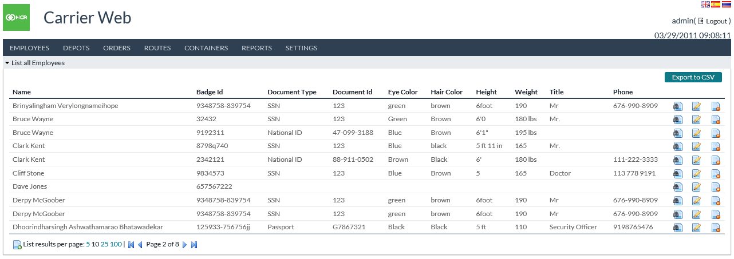

Return to: Employees

## IMPORT EMPLOYEES

Import allows users to upload a formatted file of employee information so that new employees and/or updates can be performed in mass.

FIGURE 6: IMPORT EMPLOYEE'S SCREEN

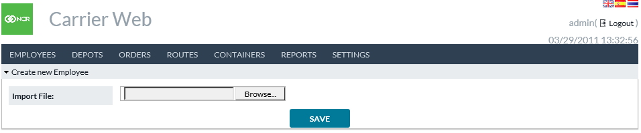

Return to: Employees

# DEPOTS

Depots are a gateway menu to the **List** **All Depots** and **Show Depot** screens. Depots are unique cash distribution locations that are usually various sites of one company or corporation contracted to provide secured cash delivery service to financial institutions.

## LIST DEPOTS

List Depots provides a listing of accessible depot locations utilizing Carrier Web

FIGURE 7: LIST DEPOTS SCREEN

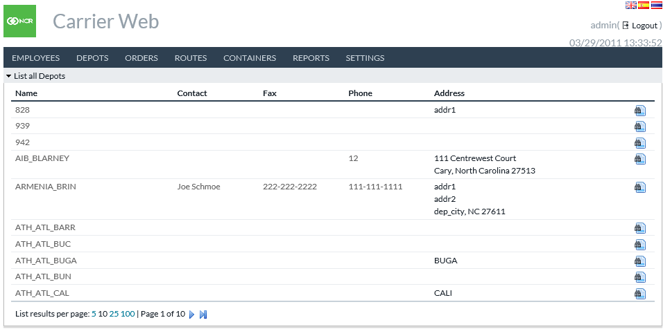

TABLE 8: DEPOTS FIELD DEFINITIONS

|  |  |
| --- | --- |
| Field | Description |
| **Name** | Name of the particular Depot |
| **Contact** | Contact person at Depot |
| **Fax** | The fax number for Depot |
| **Phone** | The telephone number for Depot |
| **Address** | Physical Address of Depot |
|  | The icon allows users to view details of the selected Depot. |

Return to: Depots

## SHOW DEPOT

To navigate to the **Show Deport** screen click on Show Depot Iconon the List All deport page. **Show Depot** lists all the fields from the **List** screen, and it also shows the OptiSuite cashpoints serviced by the depot.

FIGURE 8: SHOW DEPOT SCREEN

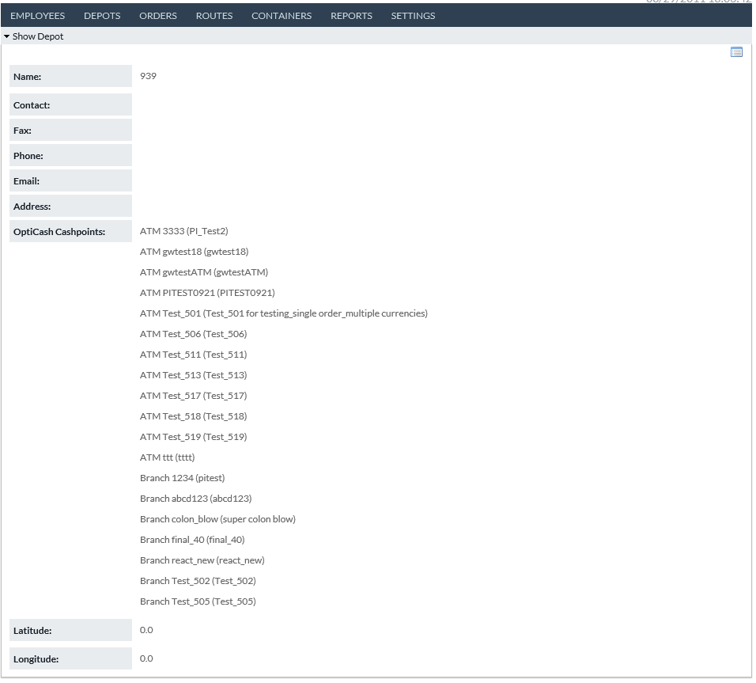

TABLE 9: SHOW DEPOT FIELD DESCRIPTIONS

|  |  |
| --- | --- |
| Field | Description |
| **Name** | Name of the Depot |
| **Contact** | Contact person at Depot |
| **Fax** | The fax number for Depot |
| **Phone** | The telephone number for Depot |
| **Address** | Physical Address of Depot |
| **OptiCash Cashpoints** | Provides a full listing of all associated OptiCash cashpoints (ATMs, Branches, & Advanced Devices) |
| **Latitude/Longitude** | The two fields allow Carrier Web to identify the physical location of the Depot for usage in the OptiTransport route optimization functionality. |

Return to: Depots

## IMPORT VAULT HISTORY

Import Vault History function allows users to load a file containing vault history information (activity and balances). This information is ultimately destined for OptiVault, but this import process allows the data to come in a more flexible format and through Carrier Web. See the separate document *Input and Output Formats Guide* for details on the format of an input file.

FIGURE 9: IMPORT VAULT HISTORY SCREEN



Return to: Depots

# ORDERS

Orders are a gateway menu to **Create, Edit, View, Action, Import, or Export orders**. Orders are divided by types such as Deliveries or Returns for ATM, Branch, Commercial, and Vault cashpoints.

Additionally, orders can be filtered by their present states such as **In-Transit** or **Ordered**.

## CREATE ORDER

Create Order, directs users to a subset of screens where ATM, Branch, Maintenance visits and Vault orders can be generated.

FIGURE 10: CREATE ORDER SCREEN

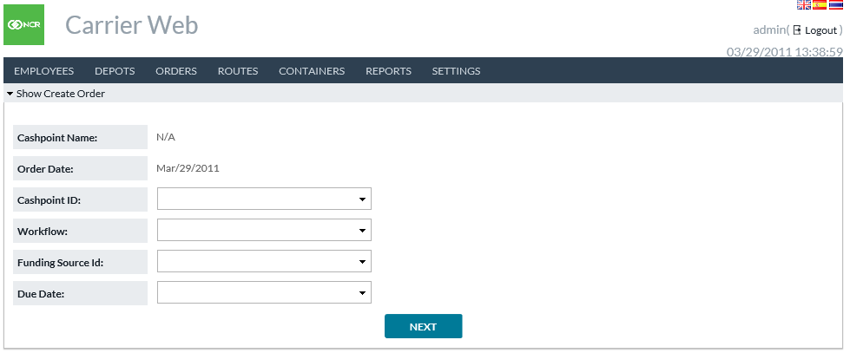

TABLE 10: CREATE ORDER FIELD DEFINITIONS

|  |  |
| --- | --- |
| Field | Description |
| **Cashpoint Name** | Autofills to assign Cashpoint Name after the user selects Cashpoint ID |
| **Order Date** | The Order Date defaults to the current business day |
| **Cashpoint ID** | A Drop down list where the user selects the unique cashpoint ID for the order being placed.  **Note**: ATM, Branch, and Vault Create Order screens are identical except for the Funding Source ID field. When the user selects ATM, Branch, or Vault from the main Create Order menu, the Cashpoint ID dropdown is automatically filtered to only include IDs of the selected cashpoint type |
| **Workflow** | The user selects the type of order to be placed: ATM Add Cash, ATM Replace Cash, Branch or Vault Delivery, and Branch or Vault Return. If Emergency orders are utilized, they will also be given unique Workflow types |
| **Due Date** | Users select the service due date for the order placed |
| **Funding Source ID** | The Funding Source ID is used for Vault orders and Branch Transfer orders. This is the other cashpoint involved in the transaction. Vault Delivery is the source of cash.  For Vault Return, it is the destination.  For Branch Transfer, it is the source of cash. |

Return to: Orders

## CREATE ORDERS – DENOMINATIONS

After selecting cashpoint type, Workflow type, and due date in the initial Create Order screen, users click **NEXT** and advance to the **Create Orders – Denominations** screen where the amounts by denomination are entered and the order is finalized.

FIGURE 9: CREATE ORDER DENOMINATION SCREEN

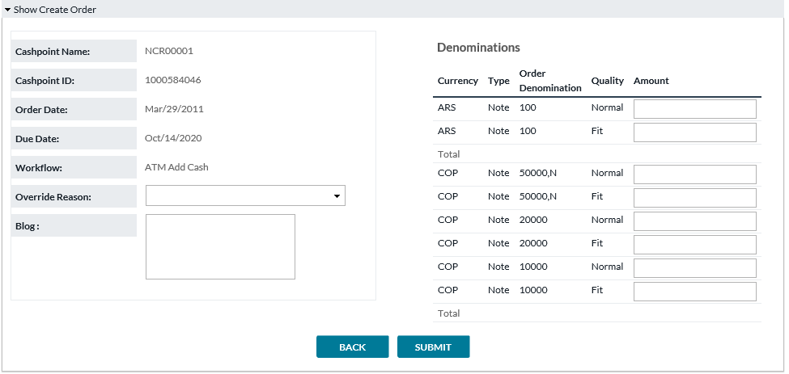

TABLE 11: VAULT SETTINGS FIELD DESCRIPTIONS

|  |  |
| --- | --- |
| Field | Description |
| **Cashpoint Name** | Autofills to assigned Cashpoint Name determined in initial Create Order screen |
| **Cashpoint ID** | Autofills to the Cashpoint ID selected in the initial Create Order screen |
| **Funding Source Type (used only for Vault Orders)** | Autofills the cashpoint type of the funding source selected in the initial Create Order screen |
| **Funding Source ID (used only for Vault Orders)** | Autofills the Funding Source ID selected in the initial Create Order screen |
| **Order Date** | The Order Date defaults to the current business day |
| **Due Date** | Defaults to the Due Date selected in the initial Create Order Screen |
| **Workflow** | Defaults to the Workflow type selected in the initial Create Order screen |
| **Override Reason** | Users must select an Override reason from a custom set list of reasons why a non-system recommended order is placed or edited |
| **Blog** | Shows the time-date flow of actions performed against any order. Will include the user ID and each action that has been performed in the processing of the order. |
| **Denominations** | Users select order amounts for each denomination available for the unique cashpoint.  For Branch Returns, orders can be defined further by note quality. Similarly, for Vaults, different note qualities can be ordered for the cashpoint, each denomination and quality will have its order field, and users can determine amounts by each denomination and quality individually.  Carrier Web is a multi-currency solution. All denomination/currency combinations will be displayed. |

Return to: Orders

## CREATE ORDERS - MAINTENANCE VISIT

Maintenance Visit is a special type of Order. They can be created and viewed under **Orders**, but their primary purpose is for the **Route Plan** function.

**For example**, if an ATM needs scheduled maintenance, it can be entered included in the Route Plan.

**Note:** Maintenance Visits have no cash amount, or current status, and are not included in Order-related functions outside of Carrier Web.

FIGURE 11: CREATE MAINTENANCE VISIT

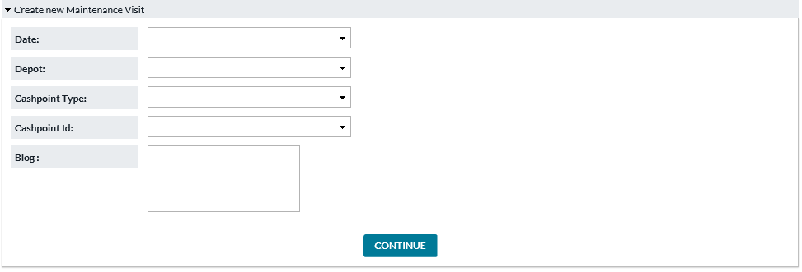

TABLE 12: CREATE MAINTENANCE VISIT FIELD DESCRIPTIONS

|  |  |
| --- | --- |
| Field | Description |
| **Date** | The date on which Maintenance Visit will be performed |
| **Depot** | Depot servicing this cashpoint |
| **Cashpoint Type** | ATM, Branch, Commercial |
| **Cashpoint ID** | The cashpoint which will be visited |
| **Blog** | Comments regarding this Maintenance Visit |

Return to: Orders

## LIST BY WORKFLOW

List by Workflow provides a by-type view of all existing orders. Here, the user can also filter by ***Current state, Order date, and Due date***.

FIGURE 12: LIST ORDERS BY WORKFLOW SCREEN

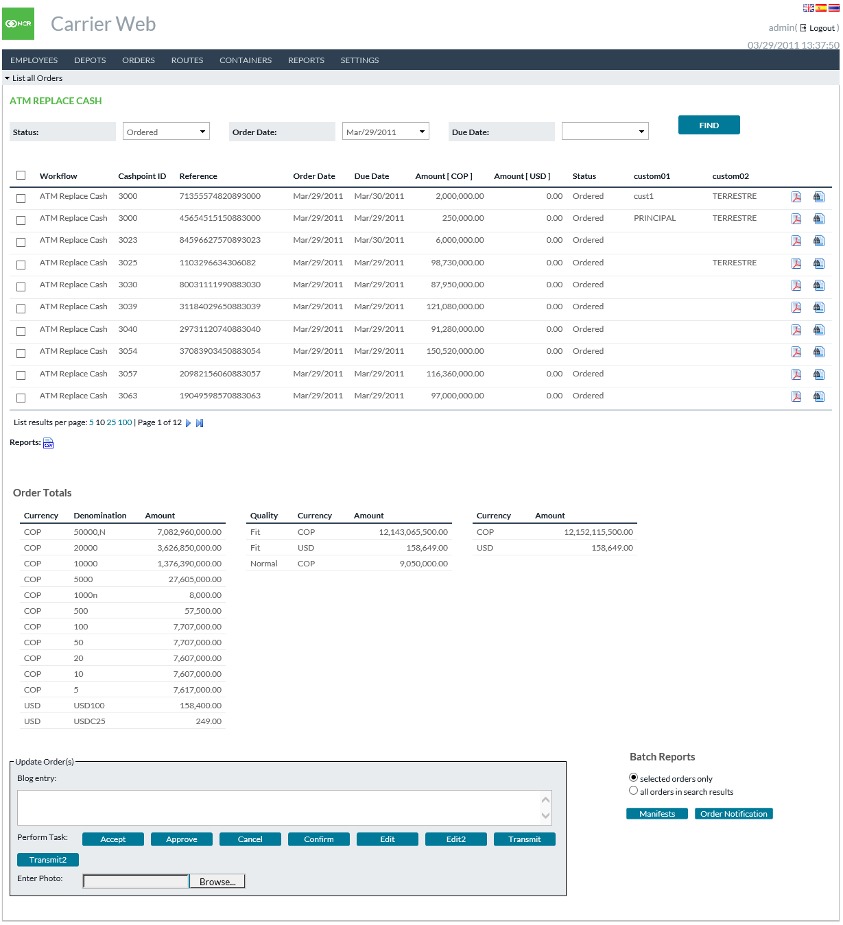

TABLE 13: LIST ORDERS BY WORKFLOW FIELD DESCRIPTIONS

|  |  |
| --- | --- |
| Field | Description |
| **Status (filter)** | Users can select the unique status they wish to view.  **For Example,** Ordered, In Transit, and cancelled. |
| **Order Date (filter)** | Users can select a unique Order Date. |
| **Due Date (filter)** | Users can select a unique Due Day. |
| **Workflow** | Shows the Workflow (or order type) for each order. |
| **Cashpoint ID** | The unique cashpoint (ATM, Branch, Vault) identification. This will correlate with the cashpoint IDs defined in the OptiSuite software. |
| **Order Reference** | Unique order identification number. |
| **Order Date** | The date Order was placed in OptiSuite |
| **Due Date** | The date selected by OptiSuite users for actual physical delivery of currency. |
| **Amount [crncy1]** | Amount of the primary currency included in this order. |
| **Amount [crncy2]** | Amount of the secondary currency included in this order. |
| **Status** | Describes the current State of the order |
| **Order Totals** | Displays the total amount of all orders in the search results. Summed by Denomination (left box), Quality (middle box) and Currency (right box). |
| **Update Orders** | Allows to update the orders by changing status, edit amounts, add notes, etc.  **Note:** Options are available only if conditions permit (privilege granted, cut-off time not past, etc.) Merely select the orders which will be changed, add a Blog Entry (note), and click one of the task buttons. |
| **Batch Reports** | Allows to generate two types of reports for either selected orders only or all results from the search criteria.  Order Manifests and Order Notifications are the two report options. |
| **Status (filter)** | Users can select the unique status they wish to view. Examples are Ordered, In Transit, and cancelled. |

Return to: Orders

## SHOW MANIFEST

By clicking on the **Show Manifest** icon  on the List All Orders screen, the user may access the order manifest for each unique order. Selecting the check boxes next to each field updates the value entered.

FIGURE 13: SHOW MANIFEST SCREEN

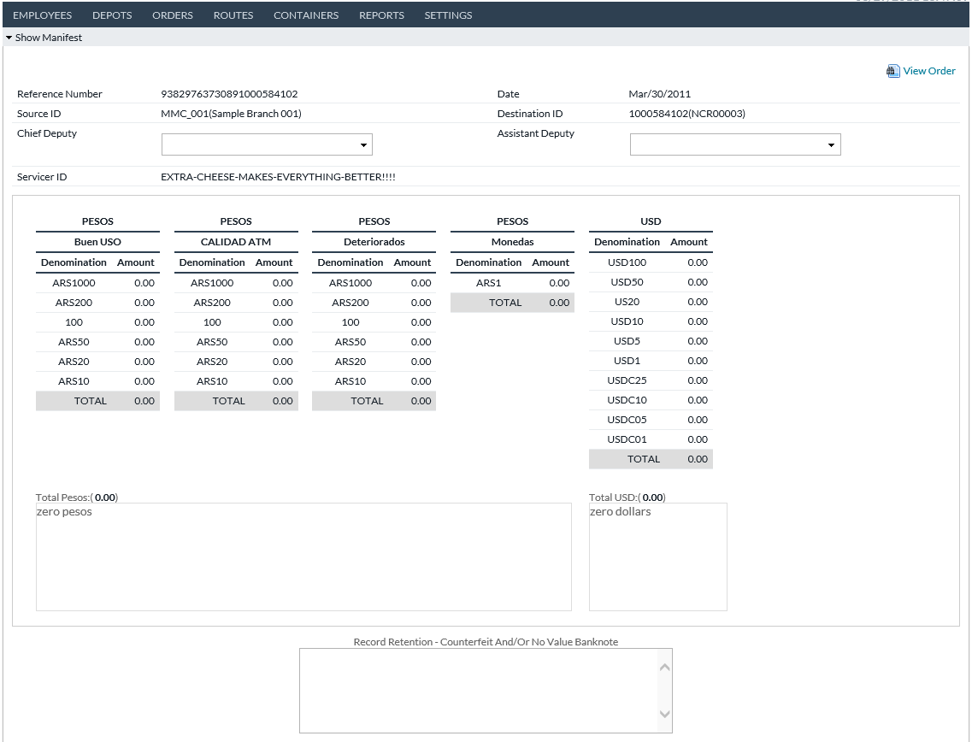

TABLE 14: MANIFEST FIELD DESCRIPTIONS

|  |  |
| --- | --- |
| Field | Description |
| **Reference Number** | Order Reference Number corresponding to OptiSuite unique order ID |
| **Date** | Current Business Day |
| **Source ID** | The ID of the origination point of currency |
| **Destination ID** | Cashpoint (ATM, Branch, Commercial, Vault) OptiSuite Cashpoint ID |
| **Chief Deputy** | Main Carrier Employee/Agent arriving at the service location |
| **Assistant Deputy** | Assistant Carrier Employee/Agent arriving at the service location |
| **Servicer ID** | The ID of Armoured Car Vendor |
| **Order Description** | Currency, Denomination, Denomination Type, and Amount of Order |
| **Comment** | Free text field for additional commentary |
| **Bag Number** | Unique ID for each transported bag |
| **Seal Number** | Unique Seal ID for each unit transported. There could be multiple units contained within a single Bag. Each wallet or unit could require a unique seal |
| **Truck** | Truck ID handling the service call |
| **Check-In** | A timestamp that currency was checked in and verified |
| **Arrival** | Arrival timestamp |
| **Back** | Allows users to migrate to the previous screen |
| **Save** | Allows users to save a copy of the Orders Manifest as defined and displayed. |
| **Get Manifest Document** | Users can access a pre-formatted printable version of the manifest |

Return to: Orders

## SHOW ORDER

By clicking on the **Show Order** icon on the List All Orders screen, the user can access detailed descriptions and the current state of each unique order.

FIGURE 14: SHOW ORDER SCREEN

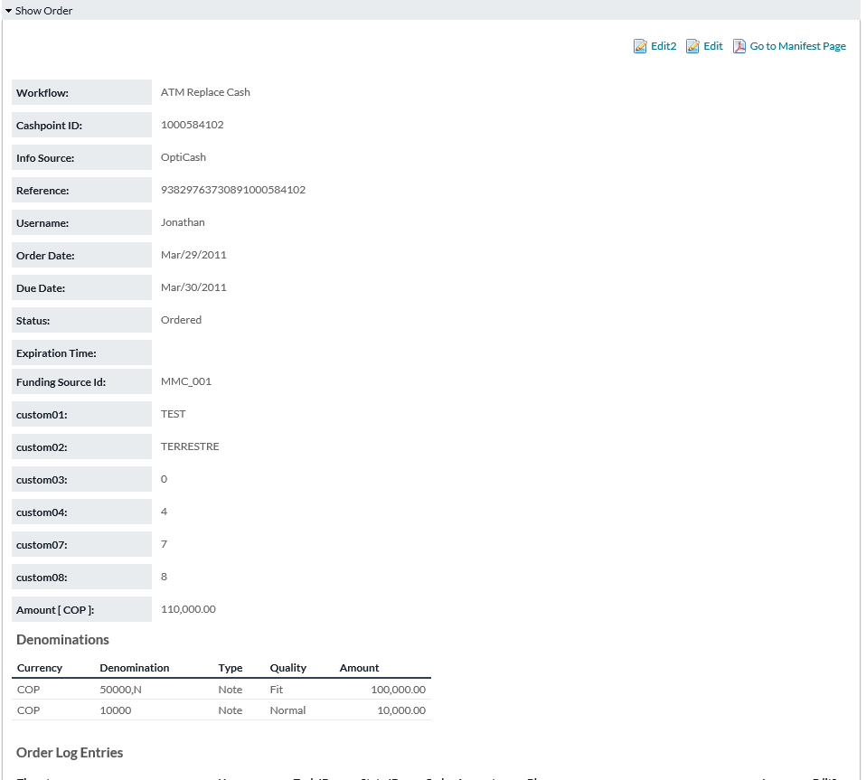

TABLE 15: SHOW ORDER FIELD DESCRIPTIONS

|  |  |
| --- | --- |
| Field | Description |
| **Workflow** | Shows the Workflow (or order type) for each order. Workflows include ATM Add, ATM Replace, ATM Emergency Add, ATM Emergency Replace, Branch Delivery, Branch Return, Branch Emergency Delivery, Branch Emergency Return, Branch Transfer, Commercial Client Delivery, Commercial Client Return, Vault Delivery, Vault Return, Emergency Vault Delivery, and Emergency Vault Return. |
| **Cashpoint ID** | Cashpoint ID to which this order belongs |
| **Info Source** | Order source. OptiCash, OptiVault, or OptiNet |
| **Reference** | Unique Order Identification Number |
| **Username** | Username of who placed the order |
| **Order Date** | When the order was placed in the system |
| **Due Date** | The Order due date for physical delivery |
| **Status** | Current Status of Order; Ordered, In Transit, etc |
| **Expiration Time** | Timestamp of the expiration time of the current state. |
| **Funding Source Type** | Depot, Vault, External Funding Source. |
| **Funding Source ID** | The ID of the other cashpoint involved in the order. This may be the source of cash, or in the case of a Return order the destination. |
| **Amount [crncy]** | The total amount of the order in the primary currency. The primary currency is shown inside **[ ].** |
| **Denominations** | Displays the full order by both Denomination and Amount by denomination |
| **Order Log Entries** | As the order moves through the workflow, The log describes the actions that have occurred.  This field describes when, who, and what has occurred and any notes (Blog entries) along the way.  The log maintains a full listing of all Blog entries including the ability to **Edit** a past log note entry.  Date, Time, and User entries cannot be edited, but notes added to a blog can be edited. |

Return to: Orders

## EDIT ORDER

By choosing the **Edit** task on the List All Orders screen, users can access the screen where an existing order can be edited.

Users can perform below actions:

* Edit values in 1-10 Custom Fields
* Alter denomination amounts
* Add notes in the Blog field

**Note**: The Edit function is only available if it's enabled by the system administrator.

FIGURE 15: EDIT ORDER SCREEN

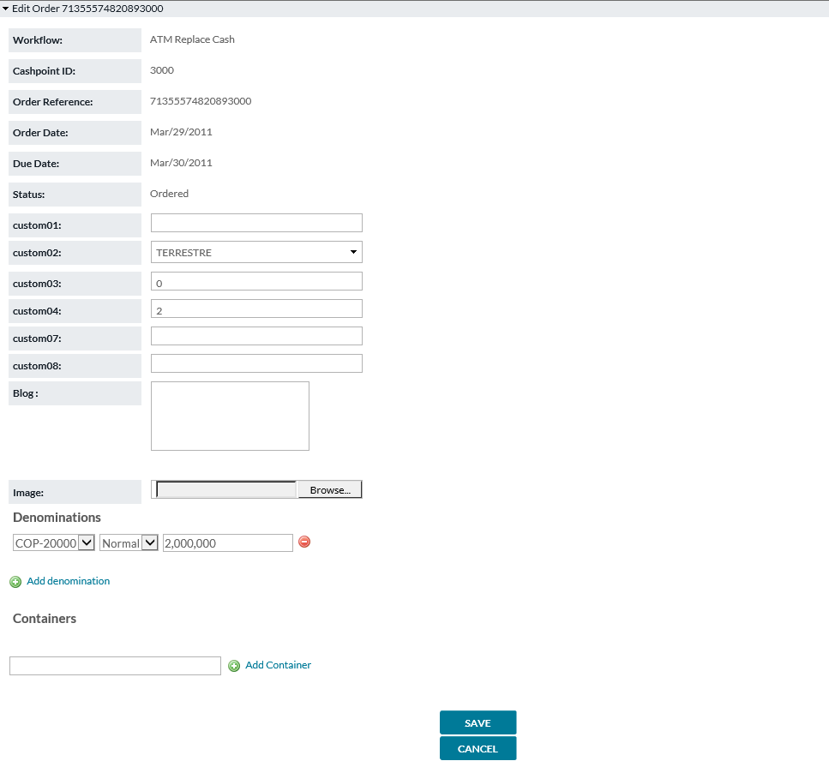

TABLE 16: SHOW ORDER FIELD DESCRIPTIONS

|  |  |
| --- | --- |
| Field | Description |
| **Workflow** | Shows the Workflow (or order type) for each order. |
| **Cashpoint ID** | Cashpoint ID to which this order belongs |
| **Order Reference** | Unique Order Identification Number generated by OptiSuite |
| **Order Date** | When the Order was placed in the system |
| **Due Date** | The Order due date for physical delivery |
| **Currency** | Currency ISO code order describes (USD, EUR, GBP, etc) |
| **Total Amount** | Total Currency Amount of the Order |
| **Status** | Current Status of Order; Ordered, In Transit, etc |
| **Custom Field 1-10** | OptiSuite software provides users with up to 10 Custom Fields that are defined by the financial institution.  This field is provided to add additional information or instruction regarding orders and their delivery |
| **Denominations** | Displays the denomination detail of cash amounts associated with this order. |

Return to: Orders

## SEARCH ORDERS

*Orders→Search* allows users to locate orders based on one or multiple criteria.

FIGURE 16: SEARCH ORDERS SCREEN

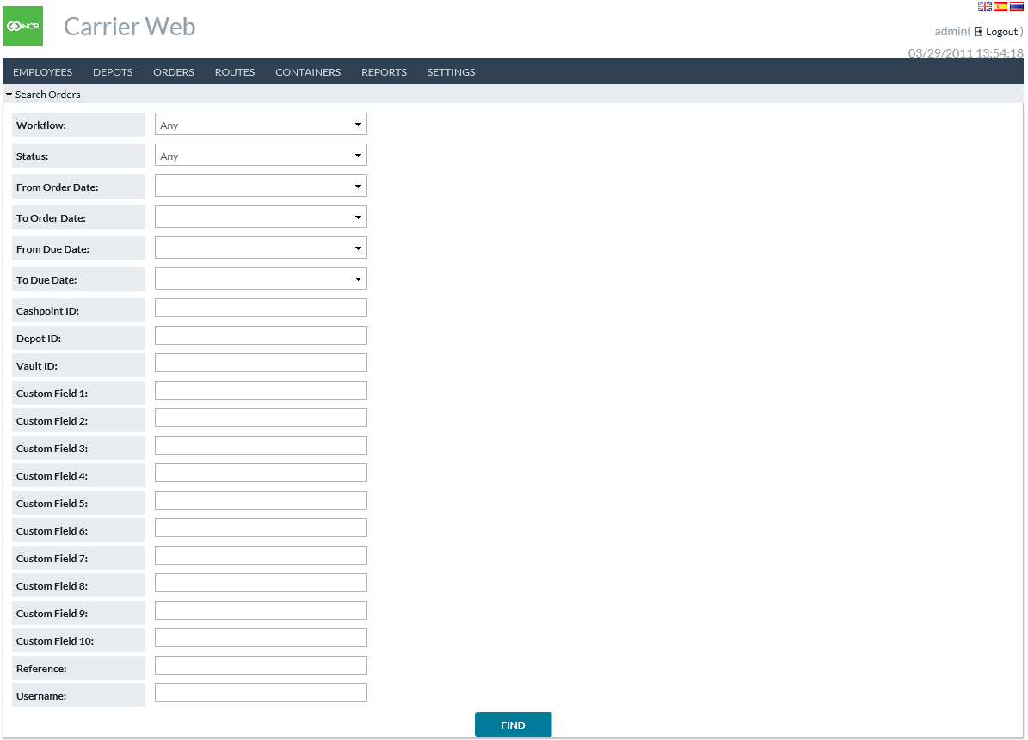

TABLE 17: SEARCH ORDERS FIELD DESCRIPTIONS

|  |  |
| --- | --- |
| Field | Description |
| **Workflow** | Users can designate **ANY** or a **Specific** workflow (order type). Workflows include ATM Add, ATM Replace, ATM Emergency Add, ATM Emergency Replace, Branch Delivery, Branch Return, Branch Emergency Delivery, Branch Emergency Return, Commercial Client Delivery, Commercial Client Return, Vault Delivery, Vault Return, Emergency Vault Delivery, and Emergency Vault Return. |
| **Status** | Users can designate **ANY** or **Specific** status |
| **From/To Order Date** | Users can select a specific Order date range, minimum date, or maximum date. Users may also leave date fields blank to select all orders regardless of Order Date |
| **From/To Due Date** | Users can select a specific Due date range, minimum date, or maximum date. Users may also leave date fields blank to select all orders regardless of Due Date |
| **Cashpoint ID** | Search for Orders of a specific **Cashpoint** |
| **Depot ID** | Search for Orders of a specific **Depot** |
| **Vault ID** | Search for Orders of a specific **Vault** |
| **Custom Field 1-10** | Search for Orders of specified values in the respective custom fields.  **Note:** A custom field may have a different meaning in ***OptiCash/OptiNet*** orders and a different meaning in ***OptiVault*** orders. This search may return both. |
| **Reference** | Search for an order using its unique reference number |
| **Username** | Username of the individual who created the order |

Return to: Orders

## EXPORT ORDERS

*Orders→Export* allows users to locate and export orders based on one or multiple criteria.

FIGURE 17: EXPORT ORDERS SCREEN

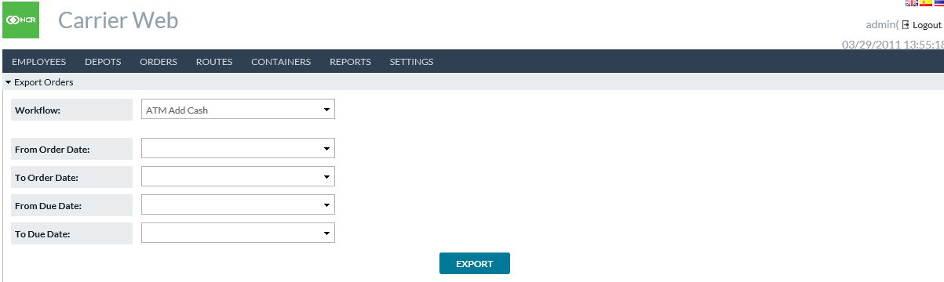

TABLE 18: EXPORT ORDERS FIELD DESCRIPTIONS

|  |  |
| --- | --- |
| Field | Description |
| **Workflow** | Users can designate **ANY** or **Specific** workflow. Workflows include ATM Add, ATM Replace, ATM Emergency Add, ATM Emergency Replace, Branch Delivery, Branch Return, Branch Emergency Delivery, Branch Emergency Return, Commercial Client Delivery, Commercial Client Return, Vault Delivery, Vault Return, Emergency Vault Delivery, and Emergency Vault Return. |
| **From/To Order Date** | Users can select a specific Order date range, minimum date, or maximum date. Users may also leave date fields blank to select all orders regardless of Order Date |
| **From/To Due Date** | Users can select a specific Due date range, minimum date, or maximum date. Users may also leave date fields blank to select all orders regardless of Due Date |

Return to: Orders

## IMPORT ORDER UPDATES

*Orders→Import* *Order Updates* allows users to import a file containing order updates. Options are given for the types of cashpoint orders that will be entered. See the separate document *Input/Output Formats Guide* for content detail of the import file.

FIGURE 18: IMPORT ORDER UPDATES SCREEN

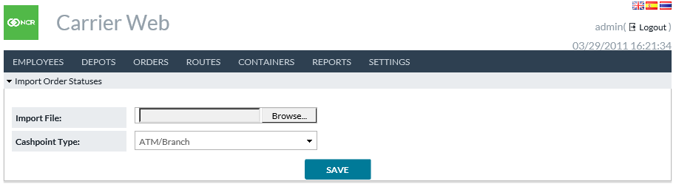

Return to: Orders

## IMPORT ATM RESIDUALS

*Orders→Import* *ATM Residuals* allows users to import a file containing ATM residual data. See the separate document *Input/Output Formats Guide* for content detail of the import file.

FIGURE 19: IMPORT ATM RESIDUALS SCREEN

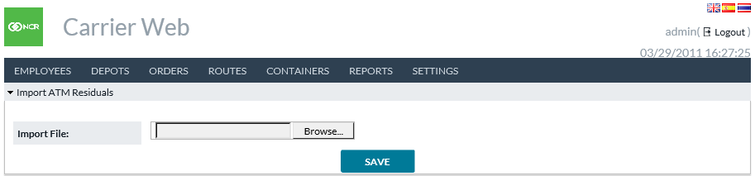

Return to: Orders

## VIEW DISPUTES

*Orders→View* *Disputes* shows the current status of disputed orders. Users may use filters to search for disputed orders to view and click additional details of a particular order if desired.

FIGURE 20: VIEW DISPUTES SCREEN

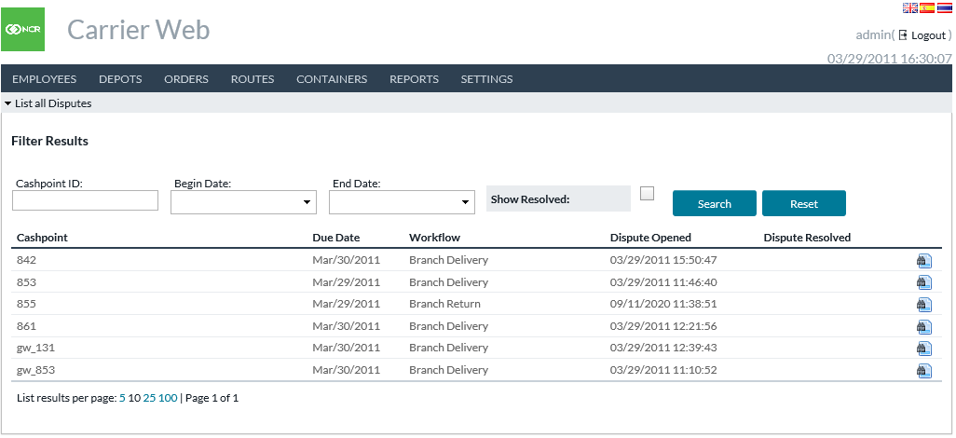

TABLE 19: VIEW DISPUTES FIELD DESCRIPTIONS

|  |  |
| --- | --- |
| Field | Description |
| **Cashpoint ID** | Search for specific cashpoint(s) if desired. |
| **Begin/End Date** | Date range to search within. This searches the Due Date field. |
| **Show Resolved** | Choose whether or not to include Resolved disputes in the search results. |
| **Cashpoint** | The Cashpoint for this order. |
| **Due Date** | The date on which this order was intended to execute. |
| **Workflow** | The type of order. Branch Delivery, Branch Return, etc. |
| **Dispute Opened** | The date/time when the dispute was first opened. |
| **Dispute Resolved** | The date/time when the dispute was resolved, or blank if not resolved. |

Return to: Orders

## INPUT DISPUTES

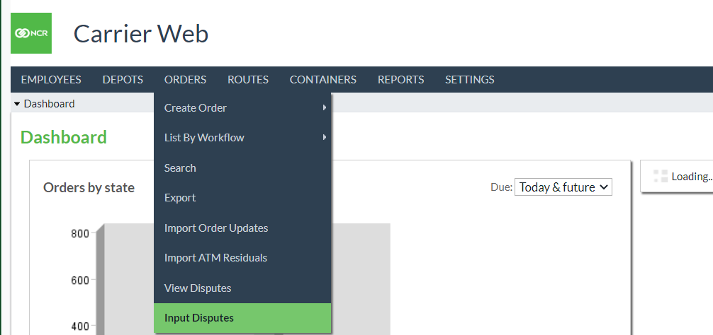

*Orders→Input* *Disputes* shows all Branch Return Orders (planned and unplanned). Users may use filters to search for confirmed or disputed orders and click to view additional details of a particular order if desired. Users can also view the manifest, and click to create/update dispute details for an order.

|  |  |
| --- | --- |
| Field | Description |
| **Due Date** | The date on which this order was intended to execute. |
| **Order Date** | The date on which this order was created. |
| **Status** | The order state (Confirmed, Disputed) |
| **Order Reference** | The reference for the particular order. |

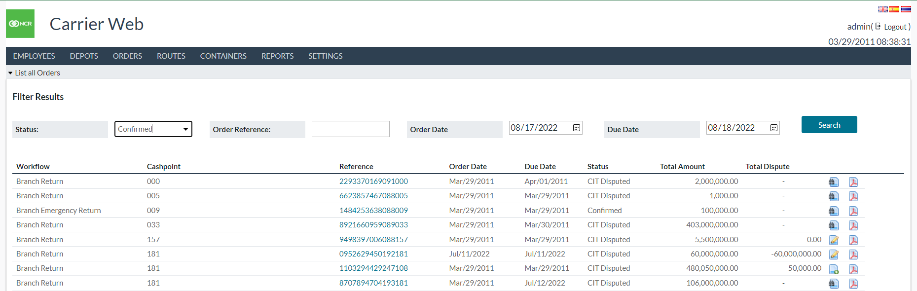

Users can click on the **Order Reference** to go to the order screen and click on the **Count Issue** task to change the order state to **Disputed** and then click on **Edit** task to enter the amount received and the difference from the actual ordered value vs the received amount will be calculated and saved as the disputed amount.

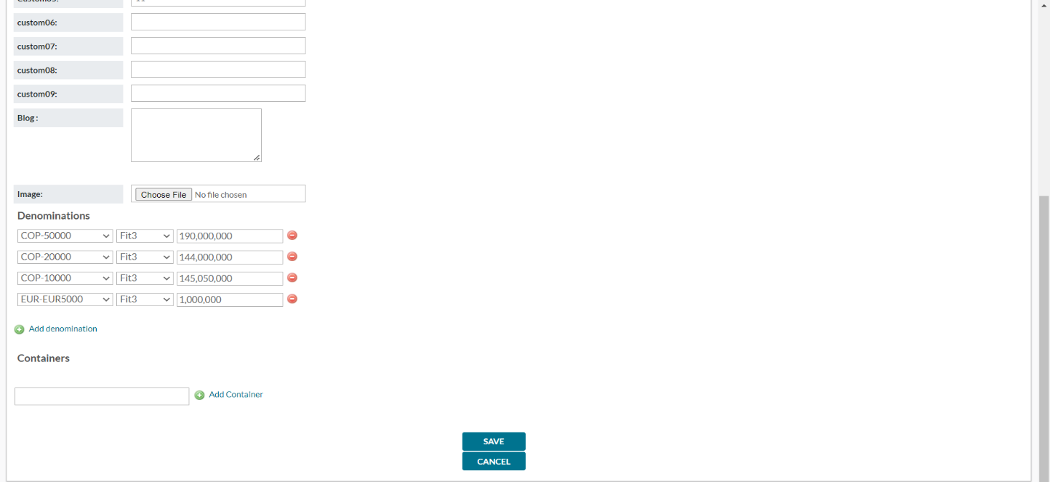

### Create/Update Dispute Details

Users can click on **Create** dispute or **Update** dispute icon to enter dispute details or update them respectively along with supporting evidence so that the total amount of dispute matches the calculated dispute amount and save dispute details.

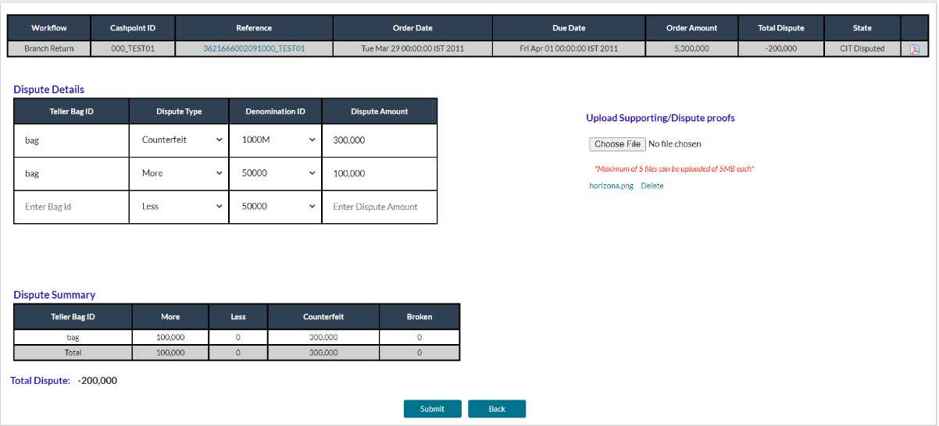

Depending on the edits in Carrier Web to branch return orders the disputed amount (amount difference between the actual order and edited order) will be calculated and fixed. See the above image and refer to the **Total Dispute** field.

After receiving the order, Carrier Web users can populate the details in the **Dispute Detail** table which then generates the **Dispute Summary** table in real-time. Evidence of these disputes can also be attached as an image or pdf file.

|  |  |
| --- | --- |
| Field | Description |
| **Teller Bag Id** | Individual order bag identifier. |
| **Dispute Type** | Dropdown to select dispute type. By default, the 4 available dispute types are: -   * **More**: If the amount exceeds compared to what is declared in the manifest. * **Less**: If the amount is less compared to what is declared in the manifest. * **Counterfeit**: If the received currency bills are invalid. * **Broken**: If the bills received are not in proper condition and therefore are not usable. |
| **Denomination Id** | Dropdown to select a denomination id from Cashpoint level defined denominations. |
| **Dispute Amount** | Numeric Text Field to enter the dispute amount for the given bag id, denomination id and dispute type. |

The Dispute Summary table shows the different amounts of disputes for all types of each bag ID, and the total dispute amount is also shown below the table.

The **Save** button will be enabled if the “**Total Dispute Amount**” matches the amount in the “**Total Dispute column**” at the top of the screen.

# ROUTES

Routes is a gateway menu to **Create, Review,** and **Plan** delivery routes. Records about the vehicles (Trucks) servicing those routes are also found here.

## CREATE NEW ROUTE

*Routes→Create New* allows users to create a new route plan.

FIGURE 21: CREATE NEW ROUTE SCREEN

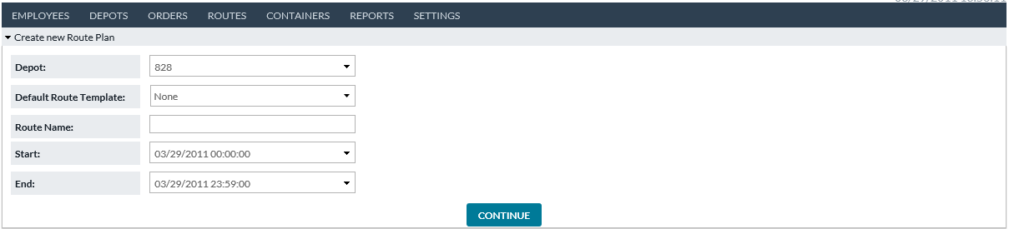

TABLE 20: CREATE NEW ROUTE FIELD DESCRIPTIONS

|  |  |
| --- | --- |
| Field | Description |
| **Depot** | Each route is assigned to a unique Depot. Users select from the predefined dropdown of depots |
| **Default Route Template** | A Default Route to use for this route plan. The Default Route functions as a template and choices made there will prepopulate values in this route plan on the following page. |
| **Route Name** | The name selected by the user for this route plan |
| **Start** | Date and time to begin this route execution. |
| **End** | Date and time to finish this route execution.  **Note**: Truck and Driver resources are considered allocated during this period and other Route Plans may not use them during the same period. |
| **Continue** | The button takes the user to CREATE/UPDATE ROUTE PLAN DETAIL to finish defining the route plan. |

Return to: Routes

## LIST ALL ROUTES

*Routes→List* *All* provides users with a list of all existing routes.

FIGURE 14: LIST ALL ROUTES SCREEN

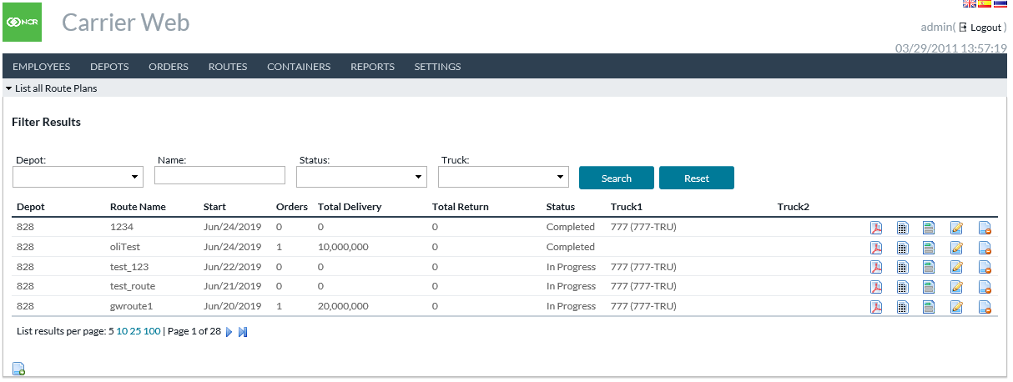

TABLE 21: LIST ALL ROUTES FIELD DESCRIPTIONS

|  |  |
| --- | --- |
| Field | Description |
| **Depot** | Depot with which the route is associated |
| **Route Name** | Unique user-defined route name |
| **Date** | Date of execution for this Route Plan |
| **Orders** | Number of existing orders |
| **Total Delivery** | Total Outstanding Deliveries for the route |
| **Total Return** | Total Outstanding Returns for the route |
| **Status** | Status of the route |
| **Truck** | Unique Truck Identification Code |

Return to: Routes

## ROUTE PLAN DOCUMENT

By clicking the **Route Plan** icon on the List All Routes screen, the user accesses a printable pdf Route Plan document that includes Truck Identification, Driver Identification, Additional Security Identification, cashpoint-by-cashpoint details including arrival and departure times, and order details. Total mileage can also be recorded on the form.

FIGURE 22: PRINTABLE ROUTE PLAN

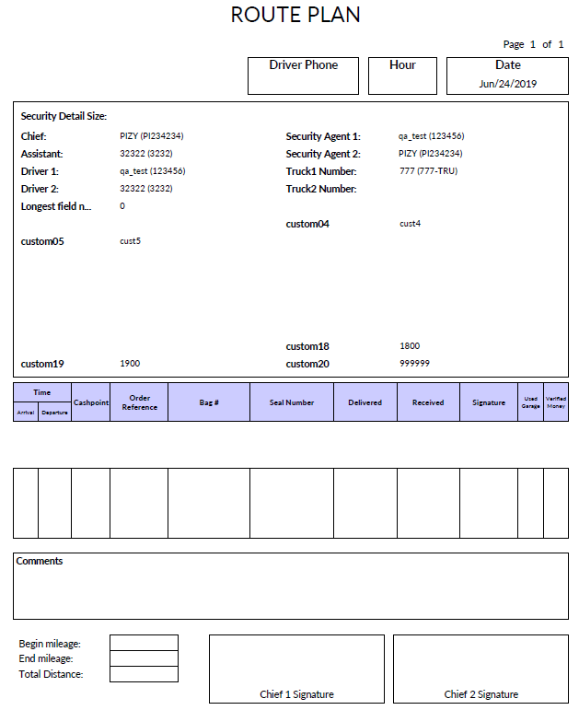

Return to: Routes

## ROUTE PLAN AUDIT

By clicking on the **Route Plan Audit** icon  on the List All Routes screen, users can view the change history of the Route Plan.

FIGURE 23: ROUTE PLAN AUDIT SCREEN

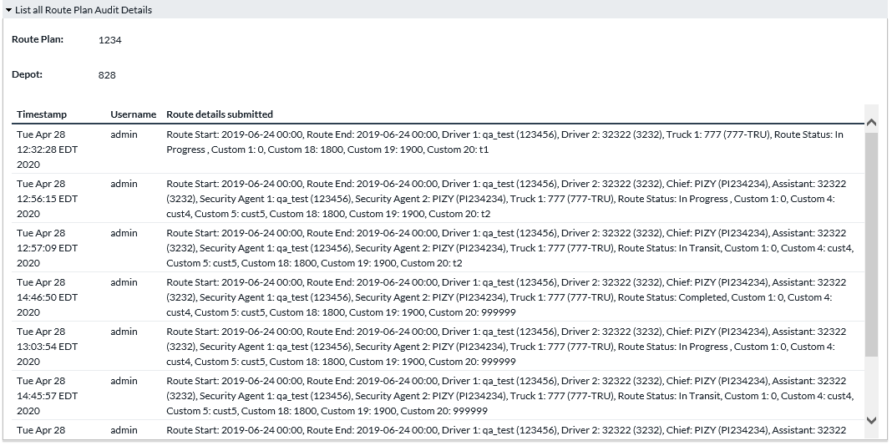

Table 22: ROUTE PLAN AUDIT FIELD DESCRIPTIONS

|  |  |
| --- | --- |
| Field | Description |
| **Timestamp** | Date and time when a change occurred. |
| **Username** | The username of the person who made the change. |
| **Route Details Submitted** | Details for the route (changed to this) |

Return to: Routes

## CREATE/UPDATE ROUTE PLAN DETAIL

Clicking on the **Edit Route Plan** icon on the List All Routes screen, or by clicking the **Continue** button on **Create New Route Plan**, the user accesses the screen where attributes of the route can be defined. Portions of the screen are interactive allowing editing and planning of routes.

FIGURE 24: CREATE/UPDATE ROUTE PLAN SCREEN

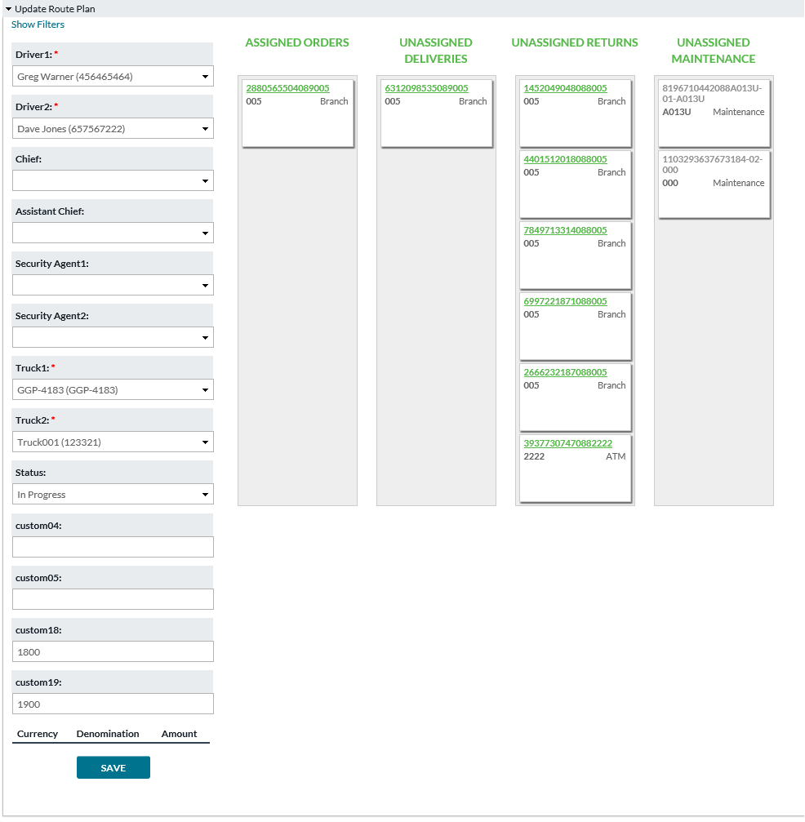

Table 23: CREATE/UPDATE ROUTE PLAN FIELD DESCRIPTIONS

|  |  |
| --- | --- |
| Field | Description |
| **Calculate Shortest Path** | With the optional OptiTranport license, this function can arrange the stops in the route according to the optimal sequence. For more information regarding this feature kindly refer to section APPENDIX A: OPTITRANSPORT  **Note**: If OptiTransport has not been licensed, **Calculate Shortest Path** will not be visible. |
| **Show/Hide Filters** | Panel to optionally filter the orders available to be added to this Route Plan. |
| **Depot** | Depot with which the route is associated |
| **Route Name** | User-defined route name |
| **Date** | Current Business Date |
| **Driver1** | Name of Primary Driver |
| **Driver2** | Name of Secondary or substitute Driver |
| **Driver3** | Name of Tertiary or substitute Driver |
| **Chief** | Additional field available for identifying members of route delivery crew |
| **Assistant Chief** | Additional field available for identifying members of route delivery crew |
| **Security Agent1** | Additional field available for identifying members of route delivery crew |
| **Security Agent2** | Additional field available for identifying members of route delivery crew |
| **Truck** | Unique Truck Identification code |
| **Status** | Status of Route Plan. Status follows a workflow configured by your institution. **For example**: In Progress > In Transit > Completed.  **Note**: Route Plan fields may be disabled (become read-only) when certain statuses are reached. Additionally, changing the Route Plan’s status may initiate order updates. See ROUTE PLAN WORKFLOW |
| **Assigned Orders** | The interactive portion of the screen shows individual orders that make up the assigned route. Order tiles can be clicked and dragged between columns to aid in the planning of routes.  The assigned Orders column reflects only those orders that are assigned to the route being reviewed/edited. |
| **Unassigned Deliveries** | The interactive portion of the screen shows individual orders that can be added to the route. Order tiles can be clicked and dragged between columns to aid in the planning of routes.  The unassigned Deliveries column reflects only those deliveries that are not yet assigned to a route. |
| **Unassigned Returns** | The interactive portion of the screen shows individual orders that can be added to the route. Order tiles can be clicked and dragged between columns to aid in the planning of routes.  The Unassigned Returns column reflects only those returns that are not yet assigned to a route. |
| **Unassigned Maintenance** | The interactive portion of the screen shows individual orders that can be added to the route. Order tiles can be clicked and dragged between columns to aid in the planning of routes.  The Unassigned Maintenance column reflects only those Maintenance Visits that are not yet assigned to a route. |

Return to: Routes

## MANAGE TRUCKS

*Routes→Manage Trucks* provides access for users to define and control the vehicles in service.

The primary screen under **“Manage Trucks”** is the **“List All Trucks”** screen, which gives a single list of all in-service trucks.

FIGURE 25: LIST ALL TRUCKS SCREEN

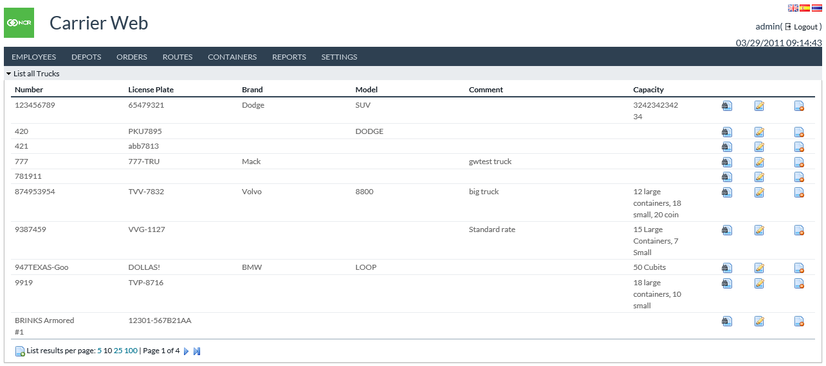

Table 24: LIST ALL TRUCKS FIELD DESCRIPTIONS

|  |  |
| --- | --- |
| Field | Description |
| **Number** | Unique Truck Identification code |
| **License Plate** | The government-issued license plate number of the truck |
| **Brand** | Make of Truck (Volvo, Ford, and others) |
| **Model** | The particular model of truck to aid in the identification |
| **Comment** | Free Text field providing the ability to note additional helpful information regarding each truck |
| **Capacity** | Total hauling capacity of each truck |

Return to: Routes

## SHOW TRUCK

By clicking on the **Show Truck** icon in the List All Trucks screen, the user can access detailed information about each truck. The **Show Truck** screen also provides gateway icons to add new trucks or edit an existing one.

FIGURE 26: SHOW TRUCK SCREEN

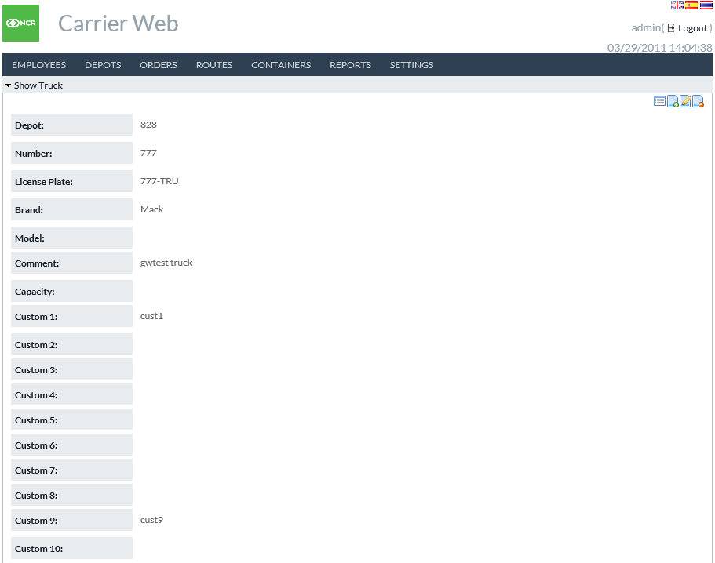

Table 25: SHOW TRUCK FIELD DESCRIPTIONS

|  |  |
| --- | --- |
| Field | Description |
| **Depots** | Depots with which this truck associates |
| **Number** | Unique Truck Identification code |
| **License Plate** | The government-issued license plate number of the truck |
| **Brand** | Make of Truck (Volvo, Ford, and others) |
| **Model** | The particular model of truck to aid in identification for security purposes |
| **Comment** | Free Text field providing the ability to note additional helpful information regarding each truck |
| **Capacity** | Total hauling capacity of each truck |
| **Custom 1-10** | Ten available custom fields to provide additional description fields for usage in defining trucks |

Return to: Routes

## CREATE NEW TRUCK

By clicking the **Create New Truck** icon  on the Manage Trucks page, the administrators can create new trucks. For field descriptions kindly refer to Show Truck

FIGURE 27: CREATE TRUCK SCREEN

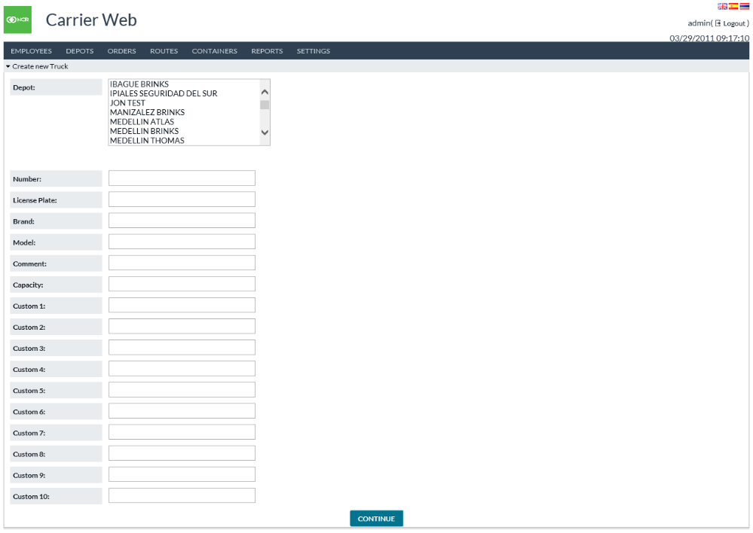

Return to: Routes

## MANAGE DEFAULT ROUTES

*Routes→Manage Default Routes* provide access to standard routes. These are similar to the templates of routes. Default Routes can be created and edited by navigating via the icons on the screen.

FIGURE 28: LIST DEFAULT ROUTES SCREEN

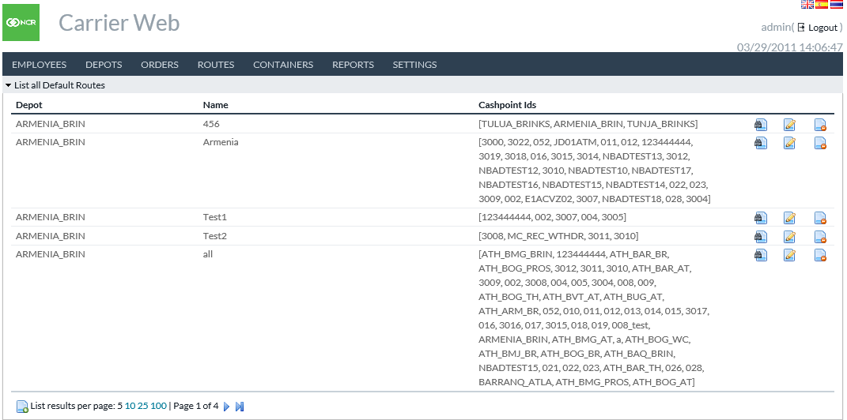

Table 26: LIST DEFAULT ROUTES FIELD DESCRIPTIONS

|  |  |
| --- | --- |
| Field | Description |
| **Depot** | Depot with which the route is associated. |
| **Name** | Unique name of the route |
| **Cashpoint IDs** | OptiSuite-defined ids of the cashpoints are included on the default route. When a new Route Plan is created using this default, then the orders for these cashpoints will be included by default (users may change it if desired). |

Return to: Routes

## SHOW DEFAULT ROUTE

By clicking on the **Show Default** **Route** icon administrator users can access detailed information about each default route. For field descriptions kindly refer to UPDATE DEFAULT ROUTE listed below.

## UPDATE DEFAULT ROUTE

By clicking on the **Update Default Route** icon administrator users can edit existing default routes.

FIGURE 29: UPDATE DEFAULT ROUTES SCREEN

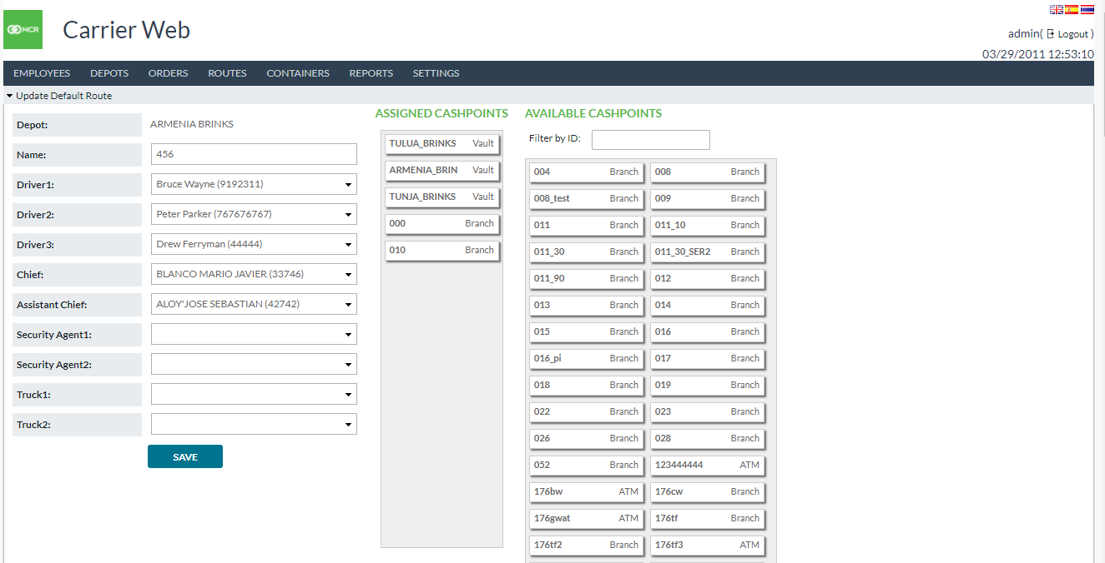

Table 27: UPDATE DEFAULT ROUTES FIELD DESCRIPTIONS

|  |  |
| --- | --- |
| Field | Description |
| **Depot** | Depot the route is associated with |
| **Route Name** | Unique user-defined route name |
| **Date** | Current Business Date |
| **Status** | The current state of Order |
| **Driver1** | Name of Primary Driver |
| **Driver2** | Name of Secondary or substitute Driver |
| **Driver3** | Name of Tertiary or substitute Driver |
| **Chief** | Supervisor/Manager level in charge of currency handling and delivery |
| **Assistant Chief** | Additional Supervisor/Manager level in charge of currency handling and delivery |
| **Security Agent1** | The available field for defining additional security personnel in currency handling and delivery |
| **Security Agent2** | The available field for defining additional security personnel in currency handling and delivery |
| **Truck** | Unique Truck Identification code |
| **Assigned Cashpoints** | The interactive portion of the screen shows individual cashpoints that make up the assigned route. Cashpoint Windows can be clicked and dragged between **Assigned** and **Available Cashpoints** to ease and speed planning routes.  The Assigned Cashpoints column reflects only those that are assigned to the default route being reviewed/edited. |
| **Available Cashpoints** | The interactive portion of the screen shows individual cashpoints that make up the assigned route. Cashpoint Windows can be clicked and dragged between **Assigned** and **Available Cashpoints** to ease and speed planning routes.  The Available Cashpoints column reflects only those that are not yet assigned to a route. |

Return to: Routes

# CONTAINERS

Containers refer to ATM cassettes, deposit bags, etc. A physical container which holds cash during transfer between locations. Carrier Web allows users to record the inventory of containers and track their movements between locations. This is often, but not always connected to Orders.

## IMPORT CONTAINERS

*Containers→Import* allows users to create containers by importing from a file. See the separate document *Input Output Formats Guide* for the format detail of the file.

FIGURE 30: IMPORT CONTAINERS SCREEN

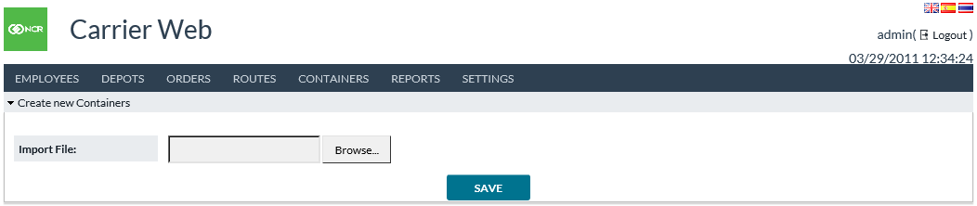

Return to: Containers

## CREATE NEW CONTAINER

*Containers→Create New* allows users to create a single container.

FIGURE 31: CREATE NEW CONTAINER SCREEN

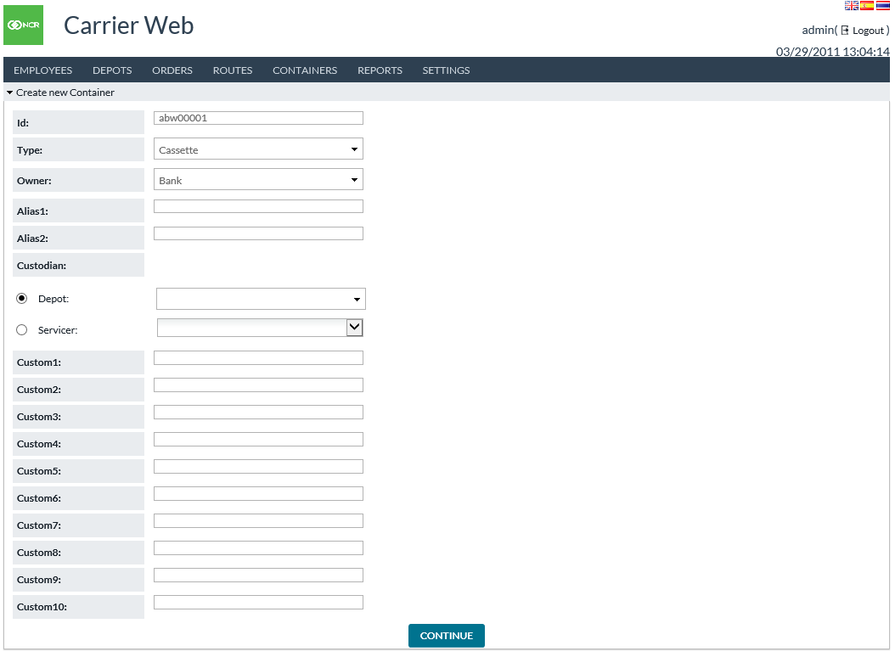

Table 28: CREATE NEW CONTAINER FIELD DESCRIPTIONS

|  |  |
| --- | --- |
| Field | Description |
| **Id** | An identifier for the container to be created. Must be different from other container IDs i.e., already in use. |
| **Type** | Type of container. Options may be configured by your institution. |
| **Owner** | Owner entity for this container. Options may be configured by your institution. |
| **Alias1, Alias2** | Optional alternative identifiers for the container. **For example**, a manufacturer’s serial number (if different from the main ID). |
| **Custodian** | The entity is responsible for this container. Refers to a Depot or Servicer from OptiCash. This is part of access control: only users associated with the chosen Depot or Servicer can use this container. |
| **Custom1-10** | Container fields whose meaning may be customized by your institution. |

Return to: Containers

## CONTAINER BULK CREATION

*Containers→Bulk Creation* allows users to create multiple containers in a block. Each container will be created with a different ID in a sequence. **For example**: ABB0001, ABB0002, ABB0003, etc. The numeric part of the sequence will begin larger than whatever largest value already exists with the same prefix – so if ABB0003 already exists, then Bulk Creation automatically starts with ABB0004. Users may choose how many containers to create in this block. Containers will be created with the values for all fields other than container ID.

FIGURE 32: CONTAINER BULK CREATION SCREEN

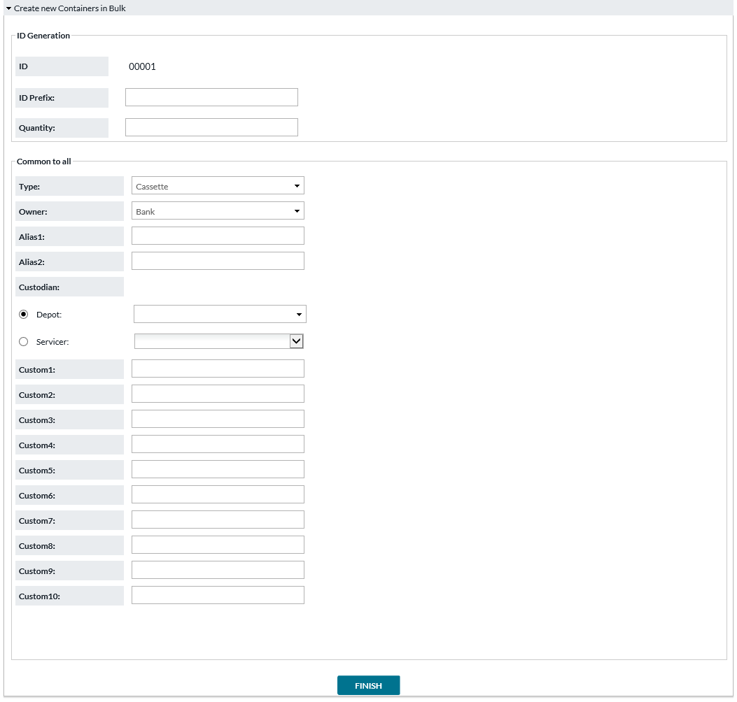

Table 29: CONTAINER BULK CREATION FIELD DESCRIPTIONS

|  |  |
| --- | --- |
| Field | Description |
| **Id** | A preview display of the container IDs that will be created. Based on the prefix entered, and the system setting Bulk Container Creation Sequence Length. |
| **Id Prefix** | Prefix to appear in front of the numeric sequence in container IDs. |
| **Quantity** | The number of containers to create in this block. |
| **Type** | Type of container. Options may be configured by your institution. |
| **Owner** | Owner entity for this container. Options may be configured by your institution. |
| **Alias1, Alias2** | Optional alternative identifiers for the container. **For example**, a manufacturer’s serial number (if different from the main ID). |
| **Custodian** | The entity is responsible for this container. Refers to a Depot or Servicer from OptiCash. This is part of access control: only users associated with the chosen Depot or Servicer can use this container. |
| **Custom1-10** | Container fields whose meaning may be customized by your institution. |

Return to: Containers

## LIST ALL CONTAINERS

*Containers→List All* allows users to view and modify containers. Container location moves and custodian assignments may be done here, as well as update and delete container fields.

FIGURE 33: LIST ALL CONTAINERS SCREEN

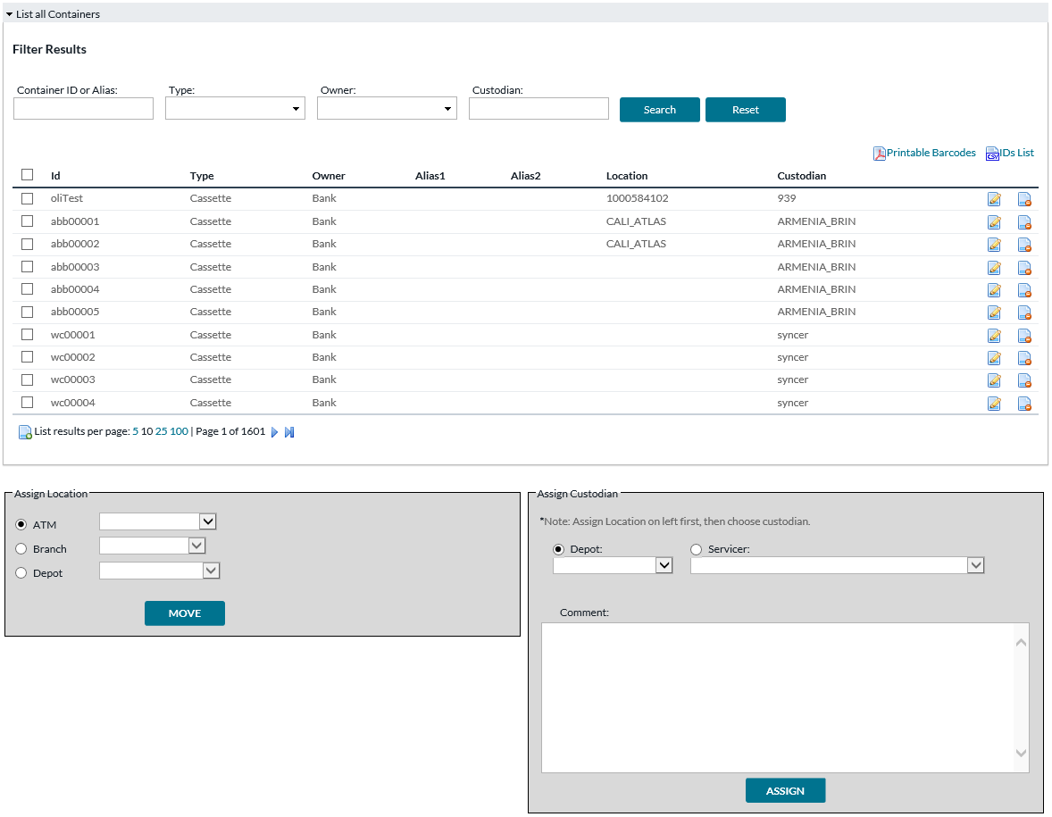

Table 30: LIST ALL CONTAINERS FIELD DESCRIPTIONS

|  |  |
| --- | --- |
| Field | Description |
| **Printable Barcodes** | Opens a PDF file containing the barcode of Container IDs for the listed containers. |
| **IDs List** | Opens a CSV file containing the IDs of the listed containers. |
| **Id** | A preview display of the container IDs that will be created. Based on the prefix entered below, and the system setting Bulk Container Creation Sequence Length. |
| **Type** | Type of container. Options may be configured by your institution. |
| **Owner** | Owner entity for this container. Options may be configured by your institution. |
| **Alias1, Alias2** | Optional alternative identifiers for the container. **For example**, a manufacturer’s serial number (if different from the main ID). |
| **Location** | Current last known location of the container. |
| **Custodian** | The entity is responsible for this container. Refers to a Depot or Servicer from OptiCash. This is part of access control: only users associated with the chosen Depot or Servicer can use this container. |
| **Edit button** | Opens the Edit Container page described below. The page is for changing the properties of the container. |
| **Delete button** | Deletes the associated container. |
| **Assign Location** | To manually move the location of selected containers, choose the new location and click the **Move** button. |
| **Assign Custodian** | To change the custodian of selected containers, choose the new custodian, optionally add a comment, and then click the **Assign** button.  **Note**: If container handover involves changing both **Location** and **Custodian** for containers, do the Location change first, since the Custodian change may cause you to lose access to the containers. |

If the user clicks the **Edit** button, then the screen below will appear.

FIGURE 34: EDIT CONTAINER

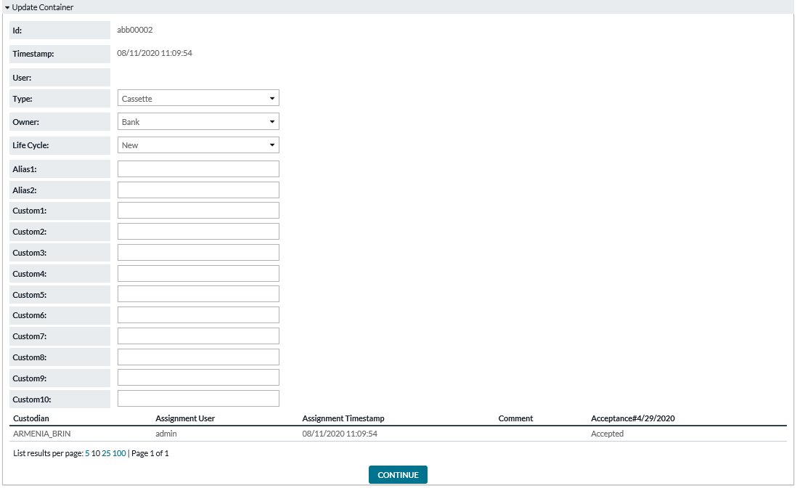

Table 31: EDIT CONTAINER FIELD DESCRIPTIONS

|  |  |
| --- | --- |
| Field | Description |
| **Id** | A preview display of the container IDs that will be created. Based on the prefix entered, and the system setting Bulk Container Creation Sequence Length. |
| **Type** | Type of container. Options may be configured by your institution. |
| **Owner** | Owner entity for this container. Options may be configured by your institution. |
| **Life Cycle** | Indicates what life cycle stage this container is in. New, In Use, Damaged, Missing, etc. – these options may be customized by your institution. |
| **Alias1, Alias2** | Optional alternative identifiers for the container. **For example**, a manufacturer’s serial number (if different from the main ID). |
| **Custom 1-10** | Container fields whose meaning may be customized by your institution. |

Return to: Containers

## CONTAINER LOCATIONS

*Containers→Locations* allow the user to either find the location of specific containers or find a location and list all containers that are currently available.

FIGURE 35: CONTAINER LOCATIONS SEARCH SCREEN



Table 32: CONTAINER LOCATIONS SEARCH FIELD DESCRIPTIONS

|  |  |
| --- | --- |
| Field | Description |
| **Search by Container** | Option to search for containers. Users may type all or part of a container’s ID or Alias1/Alias2 and then click the **Find** button. |
| **Search Locations** | Option to search for a location. Users may type all or part of the location ID and then click the **Find** button. |

If the user chooses to Search by Container, then the results page will appear as below.

FIGURE 36: CONTAINER SEARCH RESULTS SCREEN

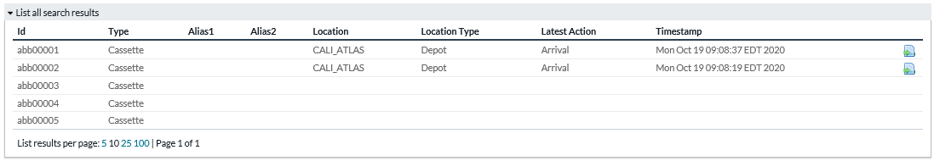

Table 33: CONTAINER SEARCH RESULTS FIELD DESCRIPTIONS

|  |  |
| --- | --- |
| Field | Description |
| **Id** | A preview display of the container IDs that will be created. Based on the prefix entered, and the system setting Bulk Container Creation Sequence Length. |
| **Type** | Type of container. Options may be configured by your institution. |
| **Owner** | Owner entity for this container. Options may be configured by your institution. |
| **Alias1, Alias2** | Optional alternative identifiers for the container. **For example**, a manufacturer’s serial number (if different from the main ID). |
| **Location** | Current last known location of the container. |
| **Location Type** | ATM, Branch, or Depot |
| **Latest Action** | Arrival, Departure, or Confirm. |
| **Timestamp** | Date and time when the Latest Action occurred. |
| **Move button** | Allows the user to manually move the container to a new location. |

If the user chooses to **Search Locations**, then the results page will appear as below.

FIGURE 37: LOCATION SEARCH RESULTS SCREEN

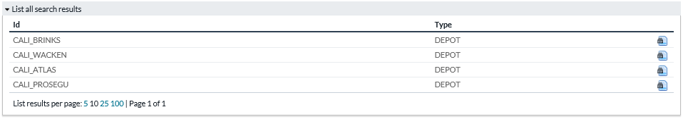

Table 34: LOCATION SEARCH RESULTS FIELD DESCRIPTIONS

|  |  |
| --- | --- |
| Field | Description |
| **Id** | Location ID. |
| **Type** | Type of location. ATM, Branch, or Depot |
| **View button** | Allows the user to see a list of the containers currently at that location. |

Return to: Containers

## CONTAINER ALERTS

*Containers→Alerts* allow users to view alert messages regarding container actions. **For example,** A container was marked present at a location (during Stock-Taking), or a container was marked missing at an ATM when the order record states it should have been there.

FIGURE 38: CONTAINER ALERTS SCREEN

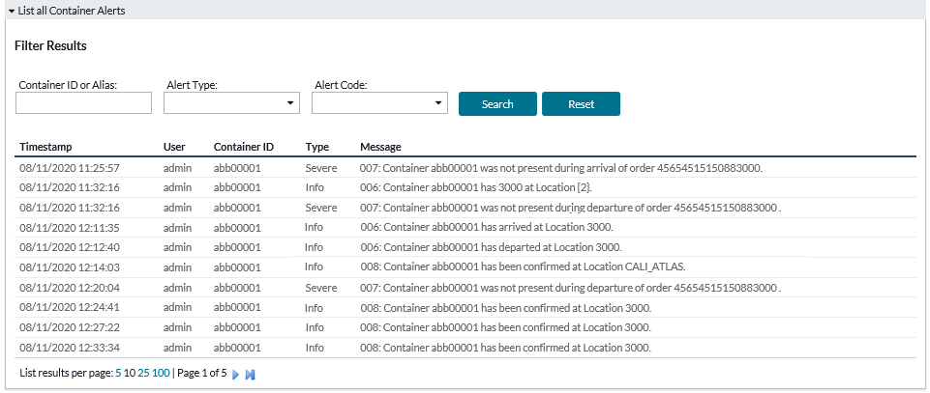

Table 35: CONTAINER ALERTS FIELD DESCRIPTIONS

|  |  |
| --- | --- |
| Field | Description |
| **Timestamp** | Date and time when the alert was generated. |
| **User** | The user who executed the action generated this alert. |
| **Container ID** | The container involved in whatever action caused this alert. |
| **Type** | Type of Alert. Info, Warn, or Severe. |
| **Message** | Description of the incident. |

Return to: Containers

# REPORTS

The Reports tab shows various reporting options.

**Note**: The reports may be enabled or disabled by your institution.

## ROUTE PLAN SUMMARY REPORT

FIGURE 39: ROUTE PLAN SUMMARY REPORT

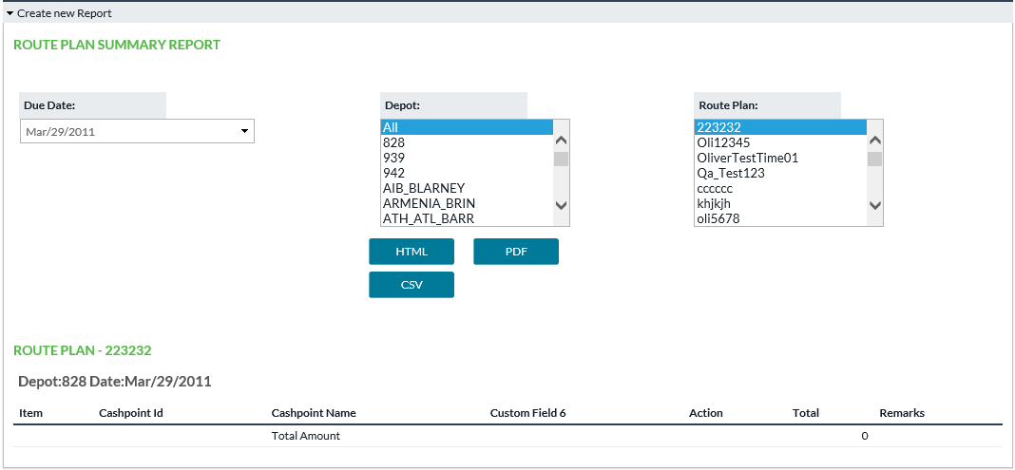

Table 36: ROUTE PLAN SUMMARY REPORT FIELD DESCRIPTIONS

|  |  |
| --- | --- |
| Field | Description |
| **Item** | Sequence of stops |
| **Cashpoint Id** | Cashpoint ID of the location being visited |
| **Cashpoint Name** | Cashpoint Name of the location being visited |
| **Custom Field** | Additional info regarding the cashpoint. Definition determined by user institution. |
| **Action** | Type of order |
| **Denomination - Pieces and Amount** | For each denomination, the number of pieces and amount value is to be transported. |
| **Total** | Total amount value |
| **Remarks** | Free field |

Return to: Reports

## ATM RESIDUALS REPORT

This report allows users to view ATM Residual data previously loaded into the system in a CSV file (spreadsheet file).

FIGURE 40: ATM RESIDUALS REPORT

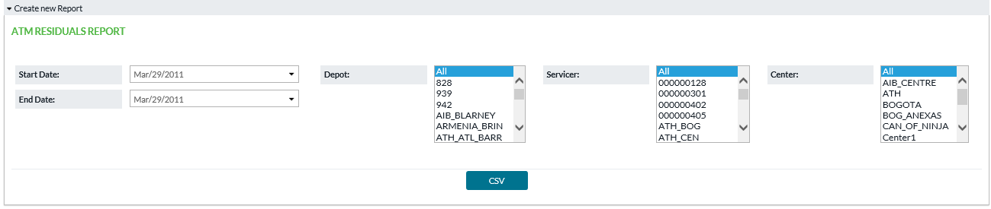

Table 37: ATM RESIDUALS REPORT FIELD DESCRIPTIONS

|  |  |
| --- | --- |
| Field | Description |
| **CASHP_ID** | The cashpoint (ATM) from which the residuals originate. |
| **RETURN_DATE** | The date on which the amounts were returned from the ATM. |
| **DENOM_ID** | Denomination ID of the cash. |
| **CASSETTE_ID** | Cassette ID, if any. |
| **PREVIOUS_DELIVERY_DATE** | Date of the prior delivery to this ATM. Presumably, the residual cash is left over from that delivery. |
| **PREVIOUS_DELIVERY_AMT** | Amount of the prior delivery to this ATM. Presumably, the residual cash is left over from that delivery. |
| **WTHDRWLS_SINCE_LAST_DELIVERY** | Count of withdrawals since last delivery. |
| **EXPECTED_RESIDUAL_AMT** | Expected residual amount based on last delivery amount and recorded withdrawals. |
| **ACTUAL_RESIDUAL_AMT** | Residual amount counted after receipt of residual cash. |
| **LINKED_ORDER** | Reference number of the prior delivery to this ATM. |

Return to: Reports

## CONTAINER ASSET REPORT

Container Asset Report allows users to view: “What containers exist” (assets list) and the current locations of the containers

FIGURE 41: CONTAINER ASSET REPORT

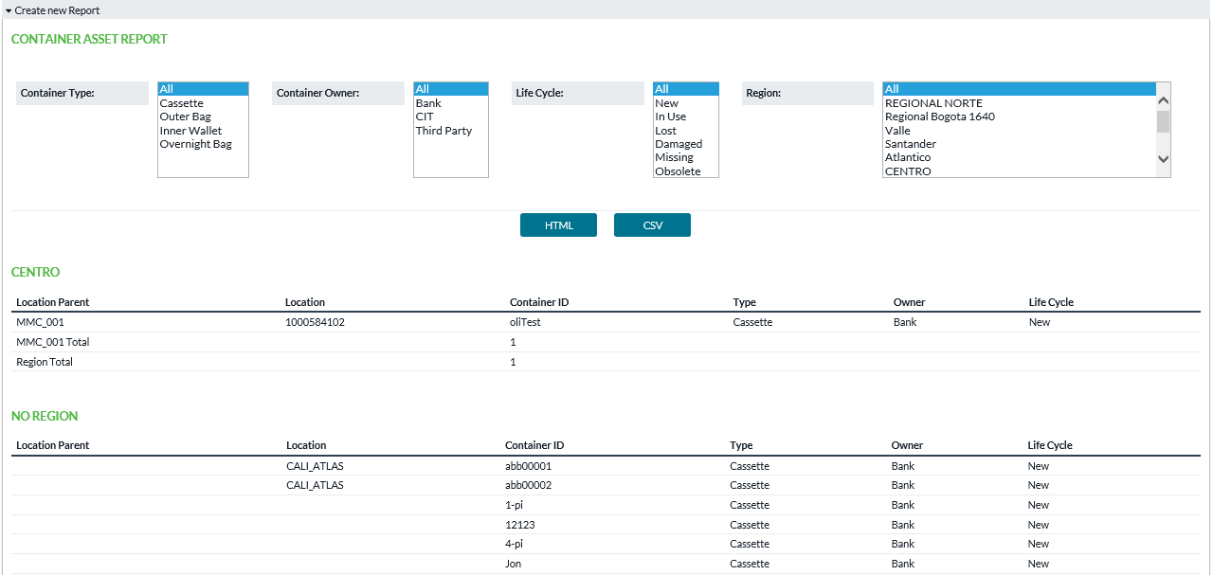

Table 38: CONTAINER ASSET REPORT FIELD DESCRIPTIONS

|  |  |
| --- | --- |
| Field | Description |
| **Container Type** | Filter report by type of container |
| **Container Owner** | Filter report by the owner of the containers |
| **Life Cycle** | Filter report by life cycle stage of containers |
| **Region** | Filter report by region |
| **Location Parent** | The parent cashpoint of the container's current location, if any. **For example**, if ATMs are linked under a Branch, then containers located at those ATMs show the Branch’s ID in the **Location Parent** field. |
| **Location** | Current location of the container |
| **Container ID** | Identifier of the container |
| **Type** | Container’s type |
| **Owner** | Container’s owner |
| **Life Cycle** | Current life cycle stage of the container |

Return to: Reports

## CONTAINER USE BY LOCATION REPORT

The purpose of this report is to give a history of container use at a location: **Example**: what Activities/events occurred.

FIGURE 42: CONTAINER USE BY LOCATION REPORT

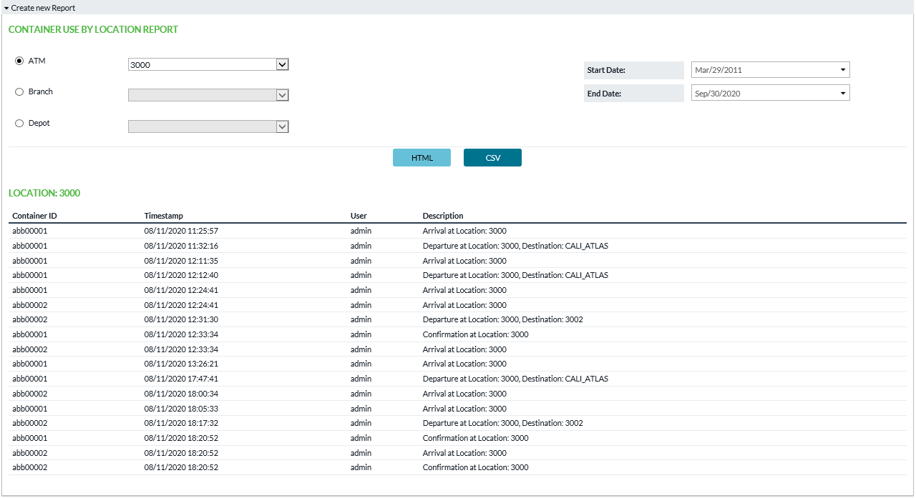

Table 39: CONTAINER USE BY LOCATION FIELD DESCRIPTIONS

|  |  |
| --- | --- |
| Field | Description |
| **Location selection** | Choose an ATM, Branch, or Depot to see that location’s use of containers |
| **Start Date/End Date** | Date range which will be included in the report |
| **HTML or CSV buttons** | Open report of the respective type |
| **Container ID** | Identifier of the container |
| **Timestamp** | Date and time when the action was recorded |
| **User** | The user who performed the action |
| **Description** | Description of the incident |

Return to: Reports

## VAULT LOAD HISTORY REPORT

This report allows the user to view what has been loaded previously via the **Import Vault History** function. The function primarily loads data into OptiVault, but it allows to load in a different format than what OptiVault stores. The records shown in the below report were loaded before being converted to OptiVault data.

FIGURE 43: VAULT LOAD HISTORY REPORT

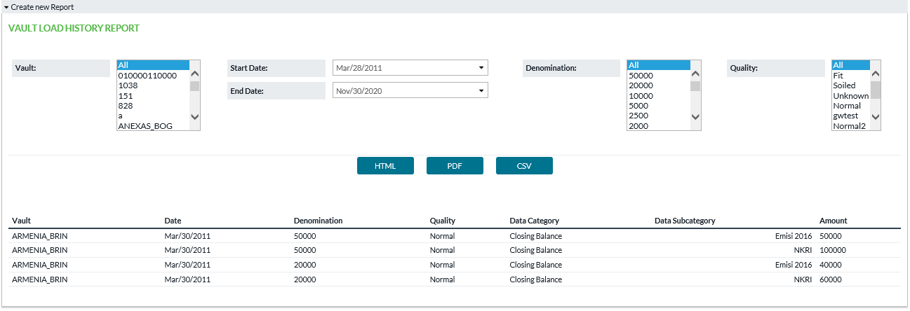

Table 40: VAULT LOAD HISTORY REPORT FIELD DESCRIPTIONS

|  |  |
| --- | --- |
| Field | Description |
| **Vault** | Choose the vault(s) which will be included in the report. |
| **Start Date/End Date** | Date range which will be included in the report |
| **Denomination** | Denomination(s) which will be included in the report |
| **Quality** | Quality(ies) which will be included in the report |
| **HTML, PDF, or CSV button** | Open report of the respective type |
| **Vault** | Vault to which this history belongs |
| **Date** | Date of history record |
| **Denomination** | Denomination of the cash |
| **Quality** | Quality of the cash |
| **Data Category** | The label used when loading this particular amount. Categories are configured by your institution and may vary. Categories often tell in which field the OptiVault amount will load. |
| **Data Subcategory** | Subcategory label used when loading this particular amount. Subcategories are defined by your institution and may vary. Subcategories are not linked to any OptiVault data field – they are used when the users reporting the data desire to break it into components, and the system will sum the subcategories together to find the amount for the associated Category in OptiVault. |
| **Amount** | The amount recorded from Import Vault History. |

Return to: Reports

# SETTINGS

Settings is a gateway menu that provides access to additional screens where administrator users can control Workflow Configuration, System Settings, and User Profiles.

## WORKFLOW CONFIGURATION

*Settings→Workflow Configuration* assists the Administrative user to control what info is accessible and what actions are allowed to Carrier Web users.

Configurations here are structured by each type of workflow (a.k.a. order type). Further controls are available under *Settings→Users* to map users to the vaults and depots to which they will have access.

FIGURE 44: WORKFLOW CONFIGURATION SCREEN

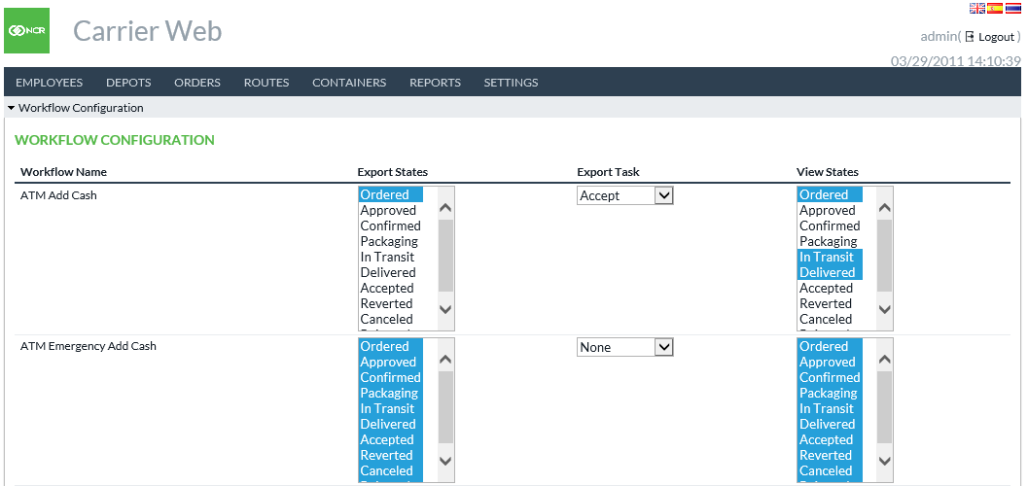

Table 41: WORKFLOW CONFIGURATION FIELD DESCRIPTIONS

|  |  |
| --- | --- |
| Field | Description |
| **Workflow Name** | Fixed field, displays Workflow/order type the user is defining |
| **Export States** | The export function performed by the Carrier Web user will include only orders currently in the states selected. |
| **Export Tasks** | The export function performed by the Carrier Web user will apply this action to the orders. **For example**, if your institution has defined an “**Accept**” task that moves orders from “**Ordered**” to the “**Accepted**” state and “**Accept**” is selected here, then when a Carrier Web user exports orders in the “**Ordered**” state those orders will be changed to “**Accepted**” state.  **Note**: The actions listed here must also be defined in the OptiCash workflow configuration (or OptiVault configuration if Vault type order). |
| **View States** | Orders in the selected states can be viewed in the *Orders→Search* *interface* (view only). |

Return to: Settings

## SYSTEM SETTINGS

*Settings→System Settings* allows administrators to determine which currency will be the primary currency and which type of order manifest document to use.

FIGURE 45: SYSTEM SETTINGS SCREEN

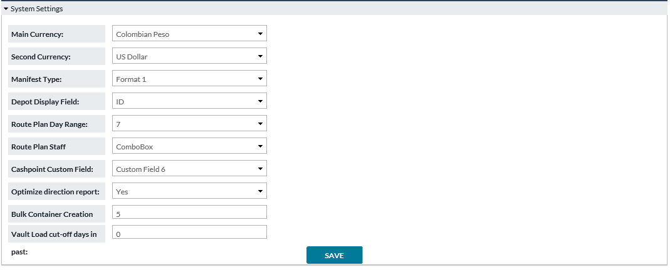

Table 42: SYSTEM SETTINGS FIELD DESCRIPTIONS

|  |  |
| --- | --- |
| Field | Description |
| **Main Currency** | The currency selected here will be given priority over other currencies in certain functions that need to sequence one currency before others. |
| **Second Currency** | The currency selected here will be the second currency displayed on pages where 2 currencies are displayed. |
| **Manifest Type** | Refers to the type of manifest document that will be generated for orders. **Format0** is default and suitable for most users. Other formats are available to serve specific operations. |
| **Depot Display Field** | Chooses between **Depot ID** and **Depot Name** field which will be displayed in the Carrier Web interface. |
| **Route Plan Day Range** | Length of date range used in displaying orders for Route Plan. Checks against the date on which the order was placed and shows those up to date.  **Example:** If this = 3, then orders placed today, yesterday, and 2 days prior are shown.  **Note**: Applies to Route Plans of type “**Depot**” and not type “**Route Definition**”. |
| **Route Plan Staff Component Type** | This feature allows a dynamic change in interface functionality. The choices are **Combo Box** and **Input Box**. Combo creates a dropdown of available security staff that can then be assigned when users are creating/editing routes. Input Box allows users to key in staff to be included in the route. |
| **Cashpoint Custom Field** | Choose one cashpoint custom field to be included in the Route Plan Summary report (default report format only). Custom fields can be defined in any way the client desires. This setting allows 1 piece of information about the cashpoint to be included in the **Route Plan Summary**. |
| **Optimize Direction Report** | Yes/No. When viewing route plan driving directions, the order of stops in the route may be optimized according to real-time traffic information. If “**Yes**”, this allows the system to override any previous sequence of stops at the time of Driving Directions creation. If “**No**”, then the existing sequence is maintained. |
| **Bulk Container Creation Sequence Length** | The number of digits which should be used during the bulk creation of new containers.  **Note**: This does not include the prefix – only the numeric suffix. |
| **Vault Load cut-off days in past** | The number of days in past beyond which Import Vault History will not be allowed. |

Return to: Settings

## USERS

*Settings→Users* allows administrators to define and limit user access to Carrier Web. Users can be granted access to particular Vaults and Depots.

FIGURE 46: USER LIST SCREEN

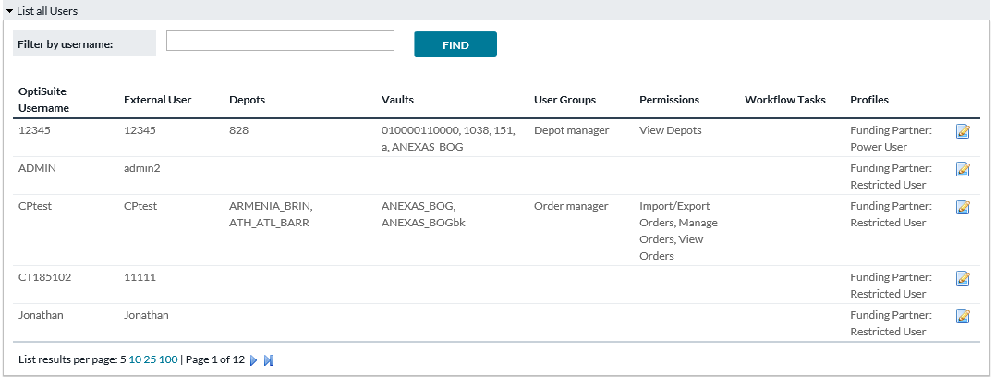

Table 43: USERS LIST FIELD DESCRIPTIONS

|  |  |
| --- | --- |
| Field | Description |
| **OptiSuite Username** | Username corresponding with OptiSuite software (OptiCash/OptiNet) |
| **External User** | If Carrier Web is configured to accept user authentication from an outside method, then this will be the user name according to that outside method. |
| **Depots** | Depot entities are configured in OptiCash. The Carrier Web user will see orders for Branches, ATMs, and Commercials which belong to the Depot(s) selected here. |
| **Vaults** | Vault entities are configured in OptiVault. The Carrier Web user will see vault orders where the Vault(s) selected here are placing the order or are the funding source of the order.  **Note**: A common configuration involves physical vault locations being listed as both “**Depot**” and “**Vault**” with the same name and in that case, you would select it in both lists. |
| **User Groups** | Shows what User Group(s)the user belongs to |
| **Permissions** | Shows what OptiVLM screens/functions the user has access to |
| **Workflow Tasks** | Shows what actions/tasks the user can perform in the processing of an Order |
| **Funding Partner (found on Update User Screen)** | This field allows CW users to be integrated with/limited by the Funding Partner functionality in OptiCash. OD Funding Partner allows Branch users in OC and ON to ship cash to/from other Branch locations. By selecting Restricted User, CW can ship cash between branches that are defined as Funding Partners in OC. By selecting Power User, CW users can ship cash between any two Branches that are supplied by the same Depot. |

Return to: Settings

## UPDATE USER

Clicking on the **Update User** icon administrators can access the settings of each user and update User assignments. **Depot** and **Vault** access can be updated by highlighting additional depots and/or vaults and clicking **SAVE**.

FIGURE 47: UPDATE USER SCREEN

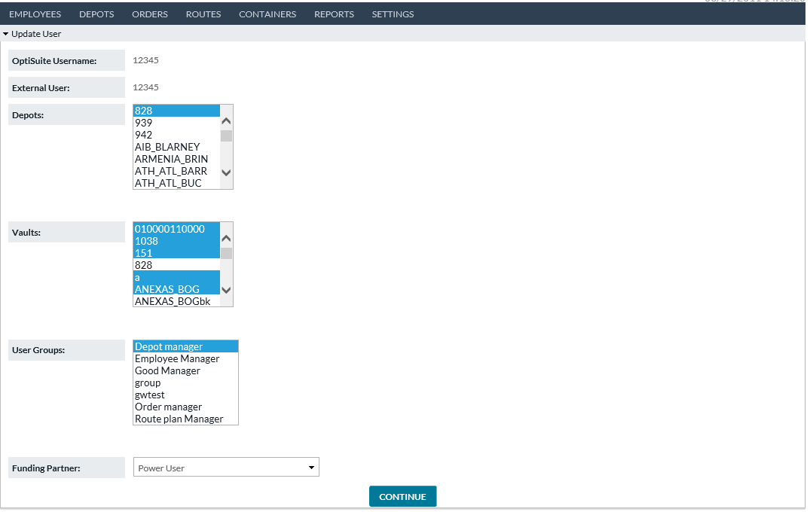

Return to: Settings

## USER GROUPS

User Groups allow administrators to create different classifications of users each defined differently by the types of functionalities they can perform or have access to in Carrier Web including **Workflow** **Tasks**. This simplifies User administration so that rights and access do not have to be defined for each unique user. Rather, new users can be easily assigned to existing User Groups thus simplifying the process. It also keeps track of rights and accesses that have been granted.

FIGURE 48: USER GROUPS SCREEN

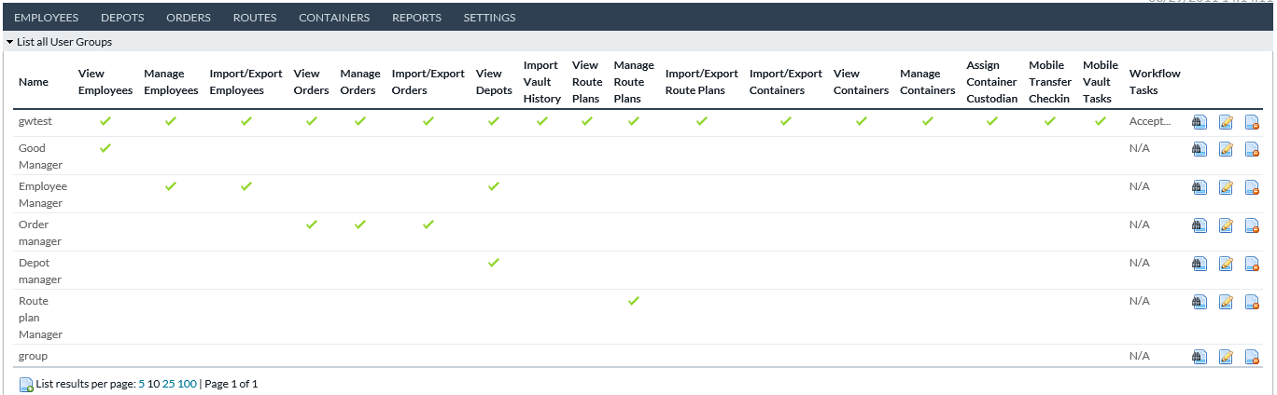

The main User Group screen lists all the existing User Groups and checkmarks below indicate the Carrier Web functionalities that are granted to the Group. These include

* Employees (View, Manage, and Import/Export)
* Orders (View, Manage, and Import/Export)
* Depots (View and Import History)
* Route Plans (View, Manage, and Import/Export)
* Containers (View, Manage, Assign Custodian)
* Mobile (Transfer Checkin = Arrival & Departure, Mobile Vault Tasks = Package Order & Container Stock). These functionalities are defined throughout this document.
* Order Workflow Tasks granted to the User Group are listed in the Workflow Task column.

Return to: Settings

## SHOW USER GROUP

Selecting the View Icon redirects the user to the **Show User Group** page which is a static single-page listing of all the User Group details as currently defined for that group.

FIGURE 49: SHOW USER GROUP SCREEN

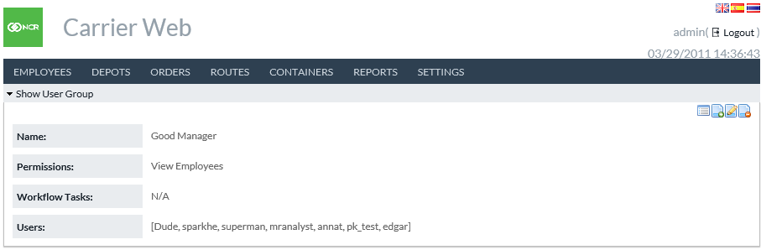

Return to: Settings

## CREATE OR EDIT USER GROUP

The screens where users can create new or edit existing **User Groups** are identical and can be navigated via the **Update** iconfor editing existing User Groups or the **Create New** icon for creating new User Groups.

When navigating to the **Edit Existing User Groups**, the pre-set Permissions and Workflow tasks will be highlighted.

FIGURE 50: CREATE/EDIT USER GROUP SCREEN

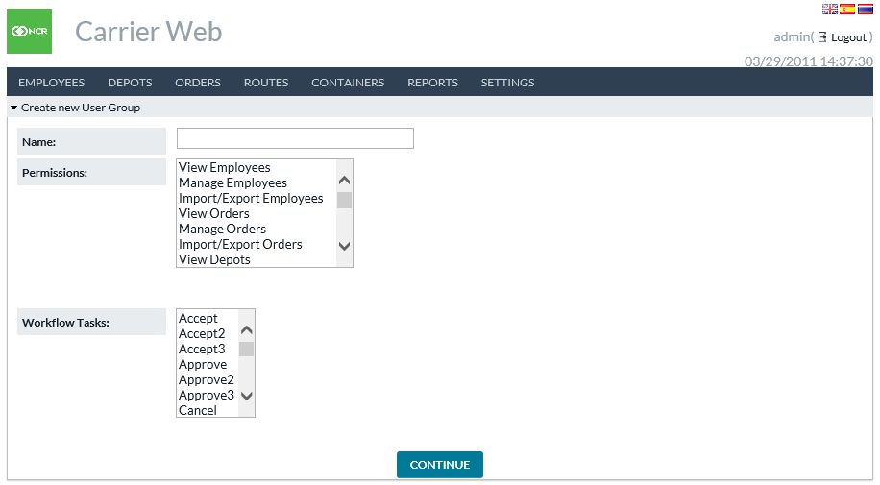

Return to: Settings

## ORDER CUSTOM FIELDS

The Custom Fields page coordinates with Custom Fields that are defined and in use in OptiCash and/or OptiVault. CW users can use the Custom Fields page in Carrier Web to determine which fields will be viewable on the *Orders→Orders Workflow* and *Orders→Search* pages in Carrier Web.

FIGURE 51: UPDATE CUSTOM FIELDS SCREEN

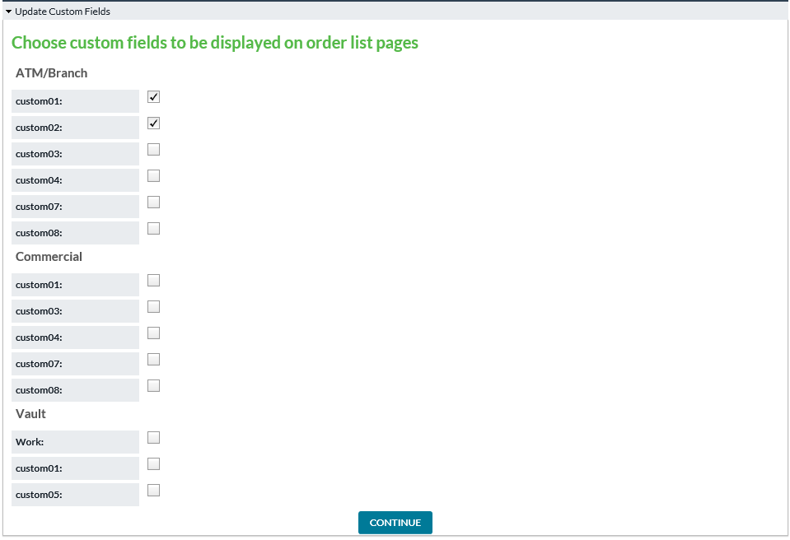

Return to: Settings

## ROUTE FIELD CONFIGURATION

Fields in Route Plan may be configured from this page. Route Plan standard fields are always present but may be set as either **Optional** or **Required**. Route Plan custom fields may be further configured, as described in the following table.

FIGURE 52: ROUTE FIELD CONFIGURATION SCREEN

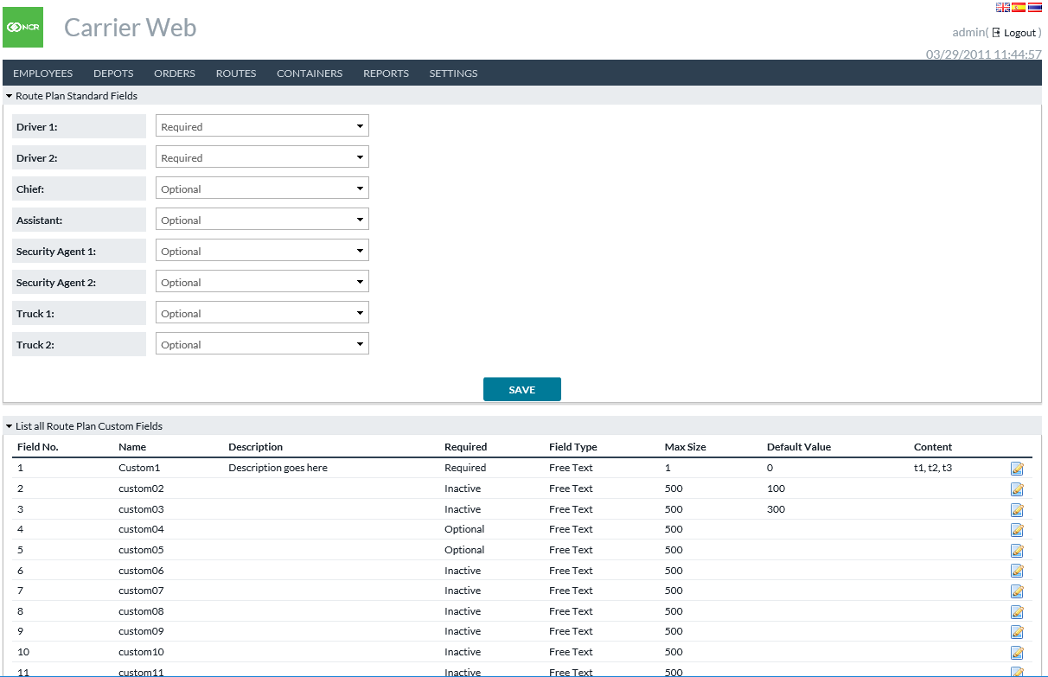

Table 44: ROUTE PLAN CUSTOM FIELDS

|  |  |
| --- | --- |
| Field | Description |
| **Field No.** | Field number. 1 to 20. |
| **Name** | Label which will be displayed for this field. |
| **Description** | A longer description or notes about the field. This will NOT be displayed in the Route Plan – just for info here in the configuration. |
| **Required** | Three options:   * **Inactive**: This field will not be displayed in the Route Plan. * **Optional**: This field will be displayed, but is not required to save the Route Plan. * **Required**: This field will be displayed and will be required to save the Route Plan. |
| **Field Type** | Two options:   * **Free Text**: The user is allowed to type in the value to be saved in this Route Plan field. * **Preset List:** The user chooses options from a dropdown menu. |
| **Max Size** | Only applicable for Free Text fields. If the user types a value, then this setting says how far they may go before the system prevents additional text. Up to 500 characters are supported. |
| **Default Value** | Value for this field will be shown when the user initially opens Route Plan. Users may override the Route Plan if desired. |
| **Content** | Only applicable for **Preset List** fields. Options in the dropdown menu are written as a comma-separated list.  **For example** “t1,t2,t3” results in options t1, t2, and t3 appearing in dropdown menu. |

Return to: Settings

## ROUTE PLAN WORKFLOW

Route Plans may follow a configurable workflow: from one status to another, with pre-defined transitions available at each point. This page does the configuration.

**Route Plan Workflows:** In the upper section, you may define the transitions allowed for a Route Plan. Each is identified by a pair of statuses – **Begin** and **End**.

**Note:** The available statuses may be modified by your institution during application installation or later configuration, up to 20 statuses total.

**Route Order Updates:** When a Route Plan changes status, the system may attempt to update the included orders. The lower section of the page here configures if and how that will occur.

**Note**: If an order update is attempted through the Route Plan, that action must follow the rules of the Order Workflow settings established in OptiCash and/or OptiVault. If Route Plan attempts to do an ordering task that is not allowed, then the order will simply not be updated.

FIGURE 53: ROUTE PLAN WORKFLOW SCREEN

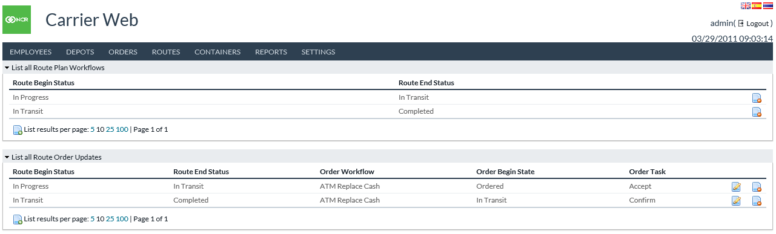

Table 45: ROUTE PLAN WORKFLOW FIELDS

|  |  |
| --- | --- |
| Field | Description |
| **Route Begin Status** | This configuration will be in effect when the Route Plan begins in this status. |
| **Route End Status** | This status is where the Route Plan will end its transition. |
| **Order Workflow** | The type of orders in the Route Plan will be included for this action. |
| **Order Begin State** | Orders in the Route Plan currently in this state will be included for this action. |
| **Order Task** | The action (Task) which will be applied to the orders in Route Plan fits the preceding criteria. |

Return to: Settings

## VAULT LOAD CONFIGURATION

See the separate document *Input/Output Formats Guide* for detailed specifications of the input file formats used in the Import Vault History function. That will refer to Categories and Subcategories used in the import process.

The definition of the Categories and Subcategories is done on the Vault Load Configuration page.

**Categories** refer to types of data that may be input during Import Vault History. The Category is effectively a label which will appear in the import file and you may map that label to its ultimate destination in an OptiVault data field. If more than one Category is mapped to the same OptiVault field, then the imported amounts are summed together.

**Subcategories** refer to additional detail (optional) which may be provided during Import Vault History but do not map to OptiVault fields directly. Subcategories will only appear under a defined Category and any amounts imported this way will be summed up to the Category level when stored in OptiVault.

FIGURE 54: VAULT LOAD CONFIGURATION SCREEN

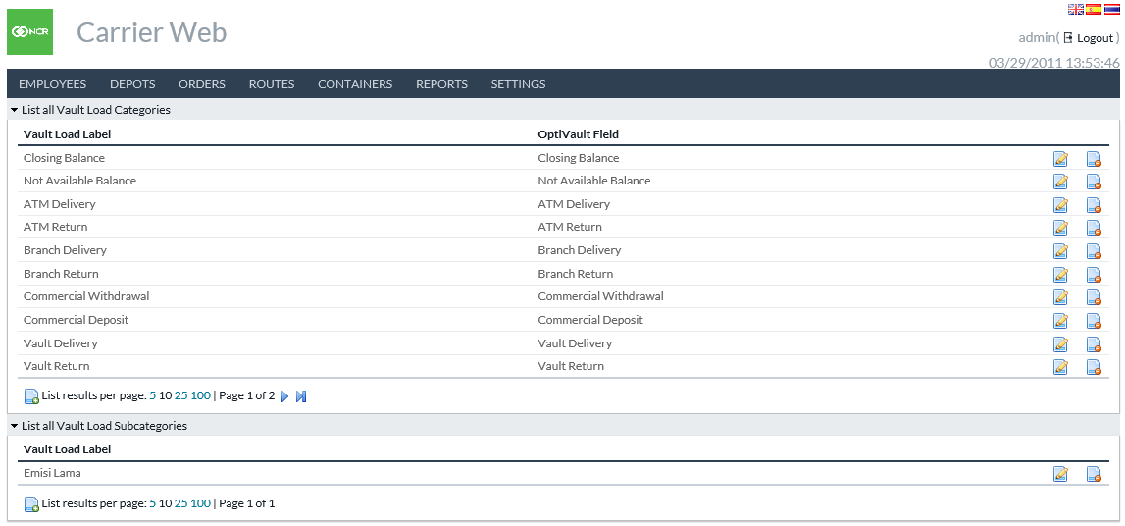

Table 46: VAULT LOAD CONFIGURATION FIELDS

|  |  |
| --- | --- |
| Field | Description |
| **Vault Load Label (Category)** | The text will appear in the input file of the Import Vault History function. |
| **OptiVault Field (Category)** | The destination data field in OptiVault for data under this Category. |
| **Vault Load Label (Subcategory)** | The text will appear in the input file of the Import Vault History function. |

Return to: Settings

## NOTIFICATION HISTORY

When background processes are completed the status information will be listed on the Notification History page. Links to download output may be available in some cases.

FIGURE 55: NOTIFICATION HISTORY SCREEN

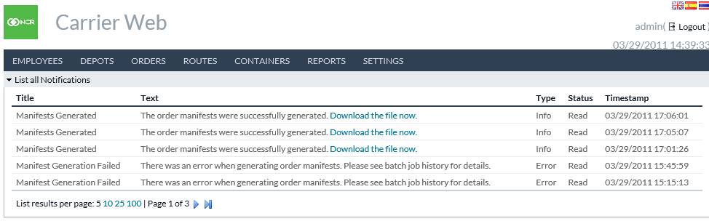

Return to: Settings

# Mobile Carrier Web

Carrier Web offers a mobile interface for accomplishing certain tasks. These are related to day-to-day activities transporting cash and managing the container inventory at various locations. The mobile interface appears when accessing the usual OptiVLM-CarrierWeb URL through a mobile device and users are given the following home menu to begin.

FIGURE 56: MOBILE HOME MENU SCREEN

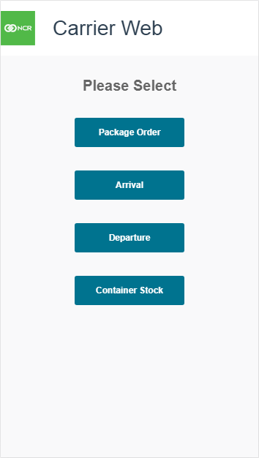

## PACKAGE ORDER

Package Order is intended for a cash transfer prior to it leaving the funding source. This function will associate an Order with Containers, which in turn allows both tracking of the containers and later alerts carrier personnel if they attempt to deliver too many or not enough containers with an order.

FIGURE 57: PACKAGE ORDER SCAN SCREEN

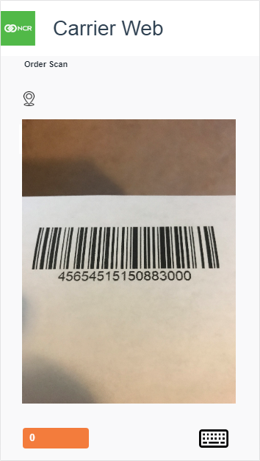

Table 47: PACKAGE ORDER SCAN SCREEN ELEMENTS

|  |  |
| --- | --- |
| Field | Description |
| **Order or Container Scan** | In the top left corner of the screen, this text indicates the mode. Initially, the user will be asked to scan or type an Order ID. Subsequently, this text switches to Container Scan and the user may then scan Containers to associate with the order. |
| **Location Indicator** | In the top left corner, underneath *Order or Container Scan indicator*. This displays the location derived from the order. |
| **Scan Window** | Uses the device camera for barcode scanning. Simply point the camera at a barcode of the order or container (as indicated by the scan mode above). |
| **Progress Indicator** | The *Orange button* in the lower left corner of the screen displays a count of containers entered for this order. Tap this button when finished entering containers to continue to the next screen. |
| **Keyboard Entry** | Keyboard icon in the lower right corner of the screen, tap this to type the order or container IDs. (Optional). This is typically only used if there is some malfunction with the barcode scan. |

FIGURE 58: PACKAGE ORDER ENTRY REVIEW SCREEN

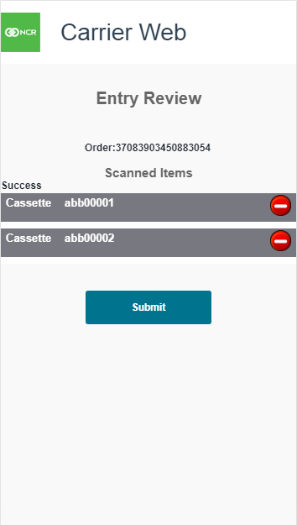

Table 48: PACKAGE ORDER ENTRY REVIEW SCREEN ELEMENTS

|  |  |
| --- | --- |
| Field | Description |
| **Order** | Order ID of the order being packaged. |
| **Scanned Items** | List of containers to be associated with this order. Users may tap the  icon to remove a scanned item. |
| **Submit Button** | Finishes the order packaging. Listed containers are associated with the indicated order, and the user is returned to the mobile home menu. |

Return to: Mobile Carrier Web

## ARRIVAL

The arrival function is intended for use when a transfer arrives at the destination. This indicates to the system that the cash and containers have arrived. Users are expected to scan the containers at this point.

FIGURE 59: ARRIVAL SCAN SCREEN

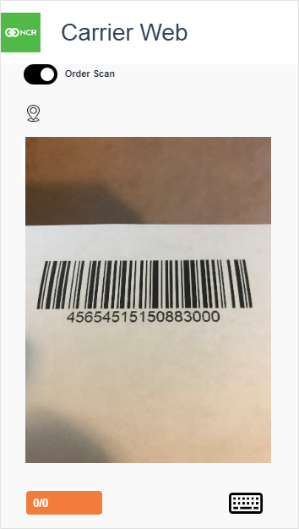

Table 49: ARRIVAL SCAN SCREEN ELEMENTS

|  |  |
| --- | --- |
| Field | Description |
| **Order or Container Scan** | The top left corner of the screen indicates the toggle mode. Users may scan an order, containers, or both. |
| **Location Indicator** | In the top left corner, underneath *Order or Container Scan indicator* displays the location derived from the order. If incorrect, the user may change it on the following screen. |
| **Scan Window** | Uses the device camera for barcode scanning. Simply point the camera at a barcode of the order or container (as indicated by the scan mode above). |
| **Progress Indicator** | *Orange button* in the lower left corner of the screen.  The first number is the count of containers scanned, and the second number is the expected number for this order (if applicable). **For example**, if scan an order first and that order was previously associated with 4 containers, then this would display “0/4”, then “1/4” after scanning 1 container, etc. Tap this button when finished scanning to continue to the next screen. |
| **Keyboard Entry** | Keyboard icon in the lower right corner of the screen, tap this to type the order or container IDs. (Optional). This is typically only used if there is some malfunction with the barcode scan. |

FIGURE 60: ARRIVAL ENTRY REVIEW SCREEN

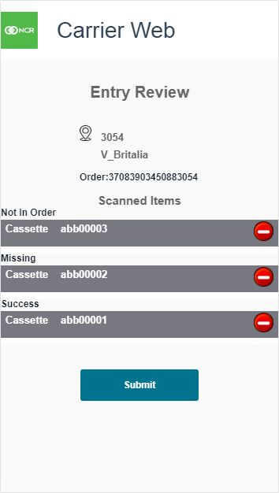

Table 50: ARRIVAL ENTRY REVIEW SCREEN ELEMENTS

|  |  |
| --- | --- |
| Field | Description |
| **Location** | A location where the order and/or containers are arriving. Tap to change location if necessary. |
| **Order** | Order ID of the arriving order, if selected previously. |
| **Scanned Items** | List of scanned containers. Users may tap the  icon to remove a scanned item. Populates 3 possible statuses: **Not In Order**: The scanned container was not expected to be part of this order. Users should consider this an alert of possible mistakes. If submitted as is, this container will be moved to this location.  **Missing**: A container was expected to be with this order but was not scanned. Users should consider this an alert of possible mistakes. If submitted as is, this container will be marked missing.  **Success**: This container was scanned as expected. |
| **Submit Button** | Finishes the Arrival function. Order and/or containers are updated in the system as when arrived. |

Return to: Mobile Carrier Web

## DEPARTURE

The Departure function is intended for use when a transfer leaves its source. This indicates to the system that the cash and containers have departed. Users are expected to scan the containers at this point.

FIGURE 61: DEPARTURE SCAN SCREEN



Table 51: DEPARTURE SCAN SCREEN ELEMENTS

|  |  |
| --- | --- |
| Field | Description |
| **Order or Container Scan** | In the top left corner of the screen, this indicates the toggle mode. The User may scan an order, containers, or both. |
| **Location Indicator** | In the top left corner, underneath *Order or Container Scan indicator* displays the location derived from the order. If incorrect, the user may change it on the following screen. |
| **Scan Window** | Uses the device camera for barcode scanning. Simply point the camera at a barcode of the order or container (as indicated by the scan mode above). |
| **Progress Indicator** | *Orange button* in the lower left corner of the screen.  The first number is the count of containers scanned, and the second number is the expected number for this order (if applicable). **For example**, if scan an order first and that order was previously associated with 4 containers, then this would display “0/4”, then “1/4” after scanning 1 container, etc. Tap this button when finished scanning to continue to the next screen. |
| **Keyboard Entry** | *Keyboard* icon in the lower right corner of the screen, tap this to type the order or container IDs. (Optional). This is typically used only if there is some malfunction with the barcode scan. |

FIGURE 62: DEPARTURE ENTRY REVIEW SCREEN

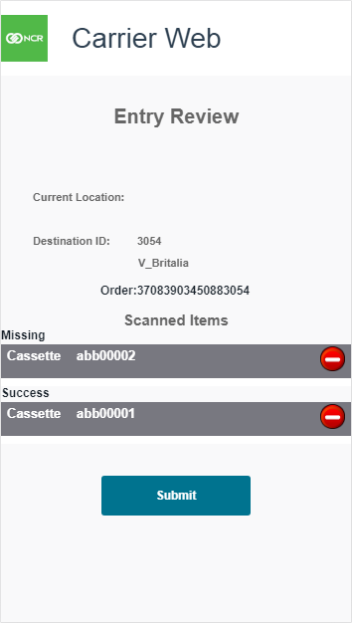

Table 52: DEPARTURE ENTRY REVIEW SCREEN ELEMENTS

|  |  |
| --- | --- |
| Field | Description |
| **Current Location** | A location where the order and/or containers are departing. Tap to change location if necessary. |
| **Destination ID** | Destination location for the order and/or containers. Tap to change location if necessary. |
| **Order** | Order ID of the departing order, if selected previously. |
| **Scanned Items** | List of scanned containers. Users may tap the  icon to remove a scanned item. Populates 3 possible statuses: **Not In Order**: The scanned container was not expected to be part of this order. Users should consider this an alert of possible mistakes. If submitted as is, this container will be moved to this location.  **Missing**: A container was expected to be with this order but was not scanned. Users should consider this an alert of possible mistakes. If submitted as is, this container will be marked missing.  **Success**: This container was scanned as expected. |
| **Submit Button** | Finishes the Departure function. Order and/or containers are updated in the system as when departed. |

Return to: Mobile Carrier Web

## CONTAINER STOCK

The Container Stock function is for inventory or stock-taking activities at a particular location – often a cash centre or container warehouse. This will update the system by confirming the current location of containers.

FIGURE 63: CONTAINER STOCK SCAN SCREEN

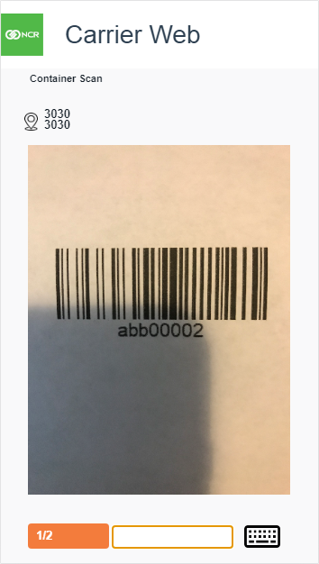

Table 53: CONTAINER STOCK SCAN SCREEN ELEMENTS

|  |  |
| --- | --- |
| Field | Description |
| **Container Scan** | In the top left corner of the screen, this indicates that you are scanning containers here. |
| **Location Indicator** | In the top left corner, underneath the *Container Scan indicator* displays the location derived from a container. If incorrect, the user may change it on the following screen. |
| **Scan Window** | Uses the device camera for barcode scanning. Simply point the camera at a barcode of the order or container (as indicated by the scan mode above). |
| **Progress Indicator** | *Orange button* in the lower left corner of the screen.  The first number is a count of containers scanned, the second number is the expected number at this location. Tap this button when finished scanning to continue to the next screen. |
| **Keyboard Entry** | *Keyboard* icon in the lower right corner of the screen, tap this to type container IDs. (Optional). This is typically only used if there is some malfunction with the barcode scan. |

FIGURE 64: CONTAINER STOCK ENTRY REVIEW SCREEN

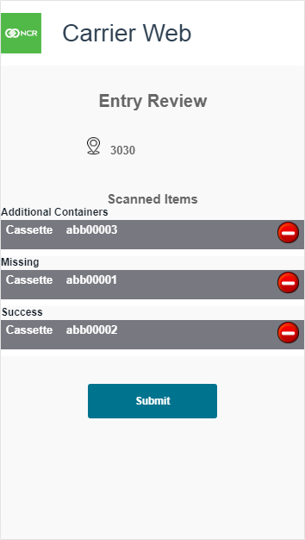

Table 54: CONTAINER STOCK ENTRY REVIEW SCREEN ELEMENTS

|  |  |
| --- | --- |
| Field | Description |
| **Location** | Location for this inventory. |
| **Scanned Items** | List of scanned containers. Users may tap the  icon to remove a scanned item. Populates 3 possible statuses:  **Additional Containers**: The scanned container was not expected to be at this location. If submitted as is, this container will be moved to this location.  **Missing**: A container was expected to be at this location but was not scanned. If submitted as is, this container will be marked missing.  **Success**: This container was scanned as expected. |
| **Submit Button** | Finishes the Container Stock function. Containers are confirmed to be at this location, or missing, respectively. |

Return to: Mobile Carrier Web

# APPENDIX A: OPTITRANSPORT

OptiTransport is an additional licensed functionality that facilitates optimization across an entire network or portion of it. It also facilitates the optimization of delivery routing based on physical location and the shortest and most efficient path to service all cashpoints on a route.

The portion of functionality concerned with network optimization of cashpoint delivery days is handled by NCR’s OptiCash product beginning with OptiCash 9.5 build 1257 and information regarding those features can be found in the *OptiCash User Guide*.

Carrier Web is concerned with the route planning portion of OptiTransport. Standard Carrier Web functionality permits the association of cashpoint deliveries and returns with a specific Depot. Within Carrier Web, users may define delivery of vehicles or “trucks” which are associated with specific Depots. Cashpoint deliveries and returns are assigned to a truck and services are then performed.

OptiTransport facilitates the association of cashpoint deliveries and returns with unique routes which can then be assigned to a truck. Using the physical location of the starting point and each cashpoint associated with the route, OptiTransport can determine the shortest route to accomplish the assigned deliveries and returns. Users can also manually define or edit routes if necessary.

## SHORTEST PATH CALCULATION PANEL

Users may utilize the **Route Travel Plans Optimization** (RTPO) available via Carrier Web. Users can associate Deliveries and Returns with a unique route. Once the relevant Deliveries and Returns are selected, Users can click on the “**Calculate Shortest Path**” which allows Carrier Web to determine the distance-optimal route for servicing the associated orders.

FIGURE 65: SHORTEST PATH CALCULATION PANEL



Table 55: SHORTEST PATH CALCULATION PANEL FIELD DESCRIPTIONS

|  |  |
| --- | --- |
| Field | Description |
| **Show or Hide Details** | Opens and Closes the Shortest Path Calculation Panel |
| **Calculate Shortest Path** | Referencing each “**Assigned Order**” on the Update Route Plan screen, OptiTransport will calculate the shortest route required to service each order. |
| **Rank** | An automated number is assigned to each Assigned Order according to their place of occurrence for the time at which they will be serviced |
| **From** | Originating location |
| **To** | Destination location |
| **Order Type** | ATM Replace Cash, Branch Delivery, Branch Return, etc. |
| **Distance** | Physical distance (km) between “From” and “To” locations |
| **Order Reference** | A unique ID is assigned to the order |

CXBanking, OptiVLM Carrier Web 10.0, Reference Guide

March 2023

NCR welcomes your feedback on this document. Your comments can be of great value in helping us improve our information products. Please contact us using the following address:

[email: xxxx@yyyy]

[web: <https://xxx.xxx.xxx>]